Kentico CMS 6.0 User’s Guide


Table of Contents

Part I Introduction 4
1 Kentico CMS overview 4
2 Signing in 5
3 User interface overview 7
Part II Managing my profile 8
1 Changing my e-mail and preferred language 8
2 Changing my password 9
Part III Getting started 10
1 Creating a new web page 10
2 Editing page content 13
Part IV Using the editor 15
1 Using What You See Is What You Get editor 15
2 Text formatting 16
3 Inserting images 16
4 Creating links 18
5 Inserting a table 19
Part V Editing structured documents 20
1 Creating a news item 20
2 Editing a news item 23
Part VI Deleting, moving and sorting documents 24
1 Deleting and restoring a document 24
2 Changing document order 26
3 Moving documents to another section 26
4 Copying a document 27
Part VII Translating documents 28
Part VIII Workflow and versioning 30
1 Publishing document 30
2 Archiving a document 31
3 Versioning and rollback 32
Part IX Security 35
1 Granting permission to edit a document 35
Part X Newsletters 38
1 Creating a newsletter issue 38
Part XI Forms 41
1 Creating and publishing a new on-line form 41
Part XII E-commerce 46
1 Creating a new product 46
2 Changing order status 49
Part XIII File import 55
1 Bulk import of files 55
Part XIV Polls 58
1 Creating and publishing a new poll 58
Part XV Forums 61
1 Creating a new forum 61
2 Moderating forum posts 65

Please note: In Kentico CMS user’s guide, we demonstrate the capabilities of Kentico CMS on the example of the sample Corporate Site. Your particular website application may vary.

Introduction

Kentico CMS overview

Kentico CMS for ASP.NET is a piece of software that allows a person without any programming knowledge to create a powerful dynamic website.
By using Kentico CMS, you will be able to manage and edit the content of your website in a quick, efficient and professional manner.

Signing in

- Open your favorite web browser and go to your website.
- At the very top of your website, click Sign in to CMS Desk. This link is only available on the sample Corporate Site. On your own website, you will need to go to http://<your website>/cmsdesk – e.g.: http://www.mydomain.com/cmsdesk.
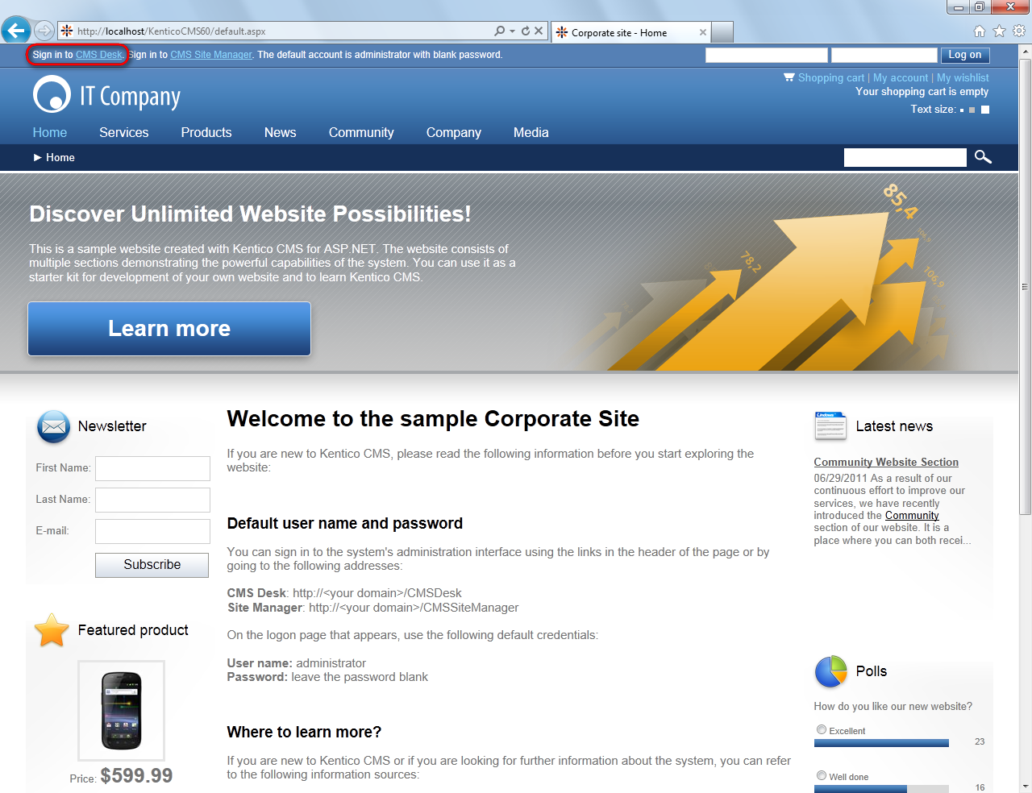

- In the following interface, type in your user name and password and click Log on.
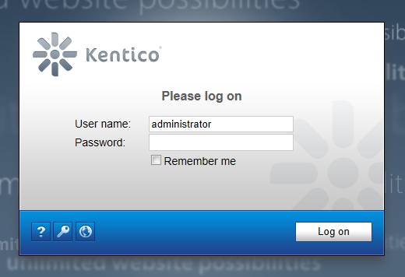

Congratulations, you’ve just log on to the CMS Desk for the first time.

User interface overview

The user interface of Kentico CMS consists of several sections. You will see that each of these sections has its specific functionality and its logical relation to the others. As a whole, the sections form a graphical interface that is easy to use and quick to navigate through.
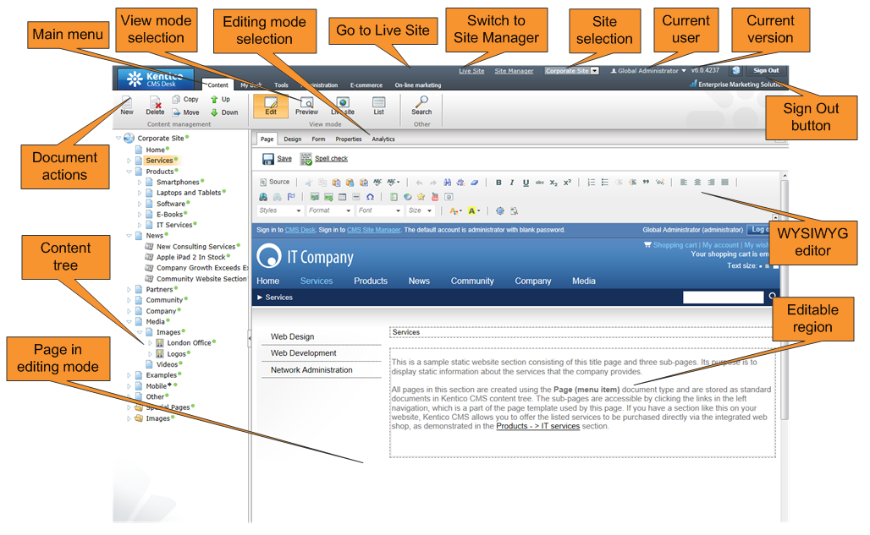
The main sections are:
- Main menu where you can switch between the Content, My Desk, Tools, Administration, E-commerce and On-line marketing sections. You will be using only the Content tab most of the time.
- Document actions toolbar where you can create, delete, edit, copy, move or sort documents.
- View mode selection that allows you to choose between editing, preview, live view and list view depending on whether you want to edit content of your website or just see how it looks in a browser.
- Content tree that displays the structure of your website and allows you to organize documents/pages in it.
- Page editing mode where you can choose the way you want to edit the content of the page. You can choose from editing of the content of your page, editing document fields, product or document properties and viewing page analytics. If you're an administrator, you can also design the page template.
- Editing/viewing space where the page chosen in the content tree is displayed in the mode that has been selected in the view and page editing toolbar.

Managing my profile

Changing my e-mail and preferred language

Now you will learn how to change your e-mail and preferred language.
- In the main menu, switch to the My Desk tab, choose Account in the ribbon menu and navigate to the Details tab.
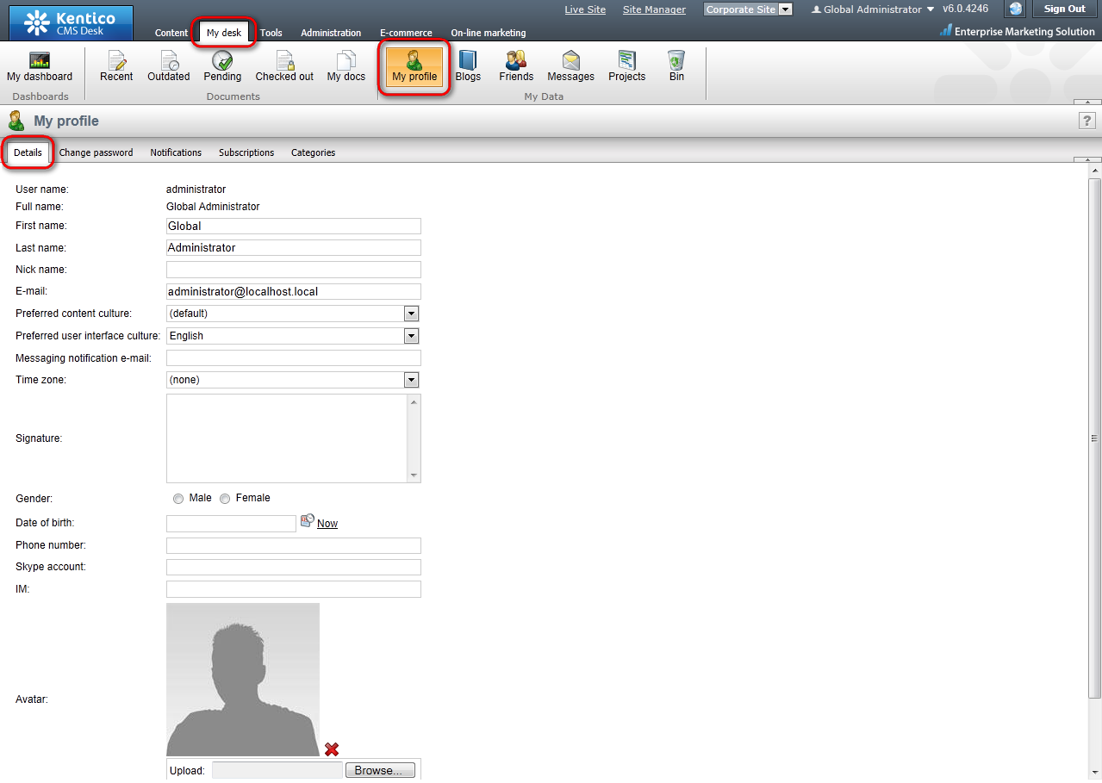
- Place the cursor into the E-mail text box and type in your e-mail address. Then click the Preferred content culture drop-down list and choose the preferred culture.
That’s how you change your e-mail address and your preferred language.

Changing my password

Now you will learn how to change your password for logging in to the CMS Desk.
- In the main menu, switch to the My Desk tab, select to Account in the ribbon menu and choose the Change password tab.
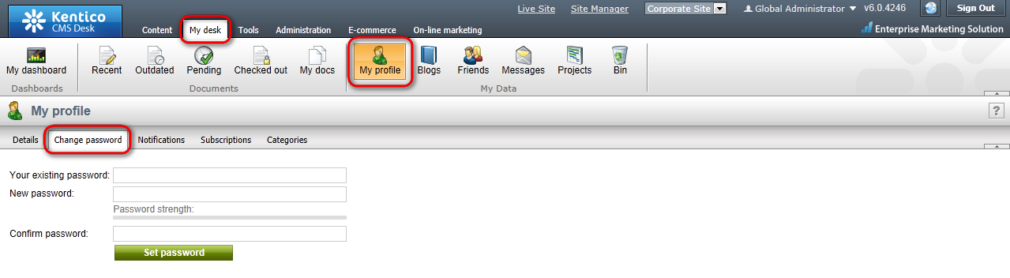
- Into the Your existing password textbox, enter your old password. (Leave blank if you don’t have to use password for signing in to the CMS Desk). Then type in your new password to the New password textbox and re-type it again to the Confirm password textbox. Click OK.
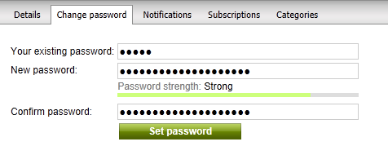
That’s how you change your password for the access to the CMS Desk.

Getting started

Creating a new web page

Let’s start from the beginning, therefore, with creating a new webpage.
- Firstly you have to choose in the Content tree where you want your new page to be located in the structure of your website.
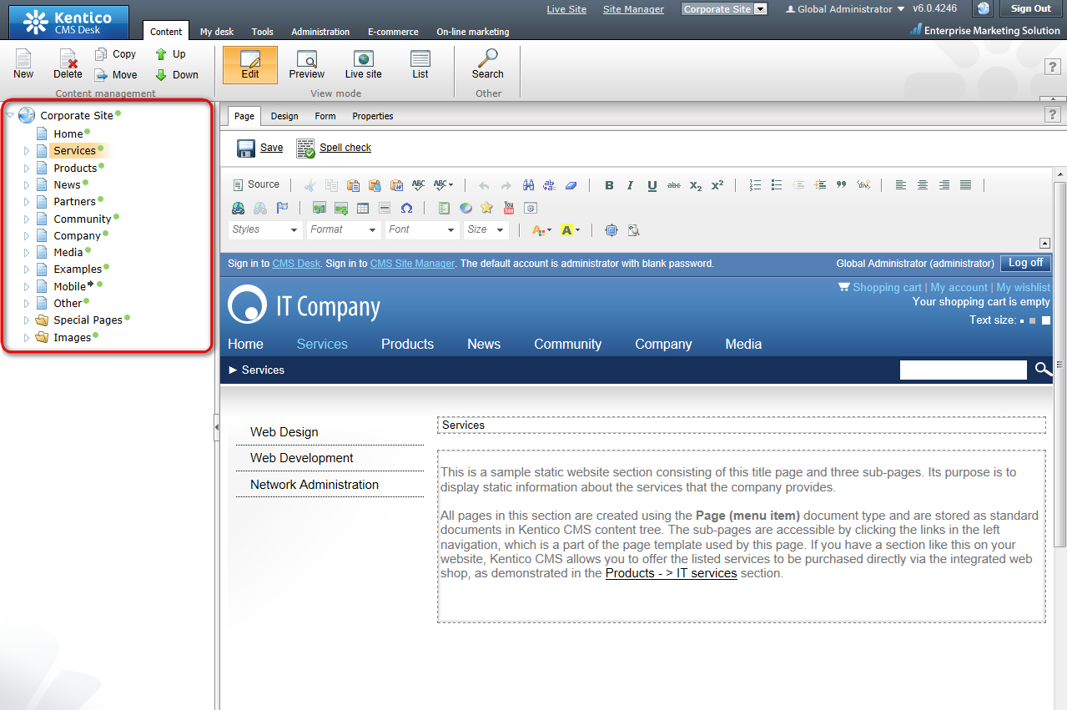
- Click on the existing document. The new page will be appended to the document you’ve just clicked on. Click the New button in the document action toolbar.
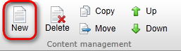

On the right side in the editing/viewing space, you should see the types of documents you are allowed to create in the chosen location.
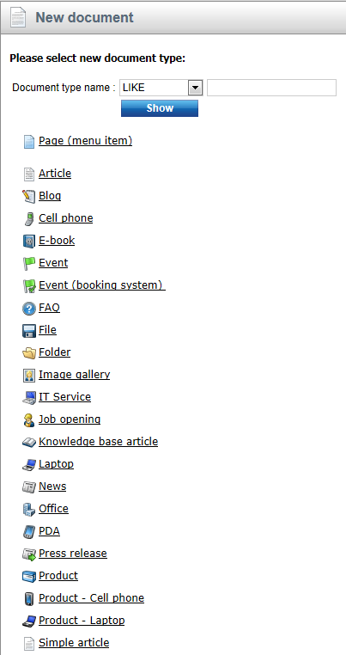

- Click the Page (menu item) option. In the following step, please enter the name of your new web page: System integration. Choose to Use an existing page template and select the Corporate site/Corporate Site - Simple text template. If you're an administrator, you can also choose to create a blank page and create it from scratch. Click Save.
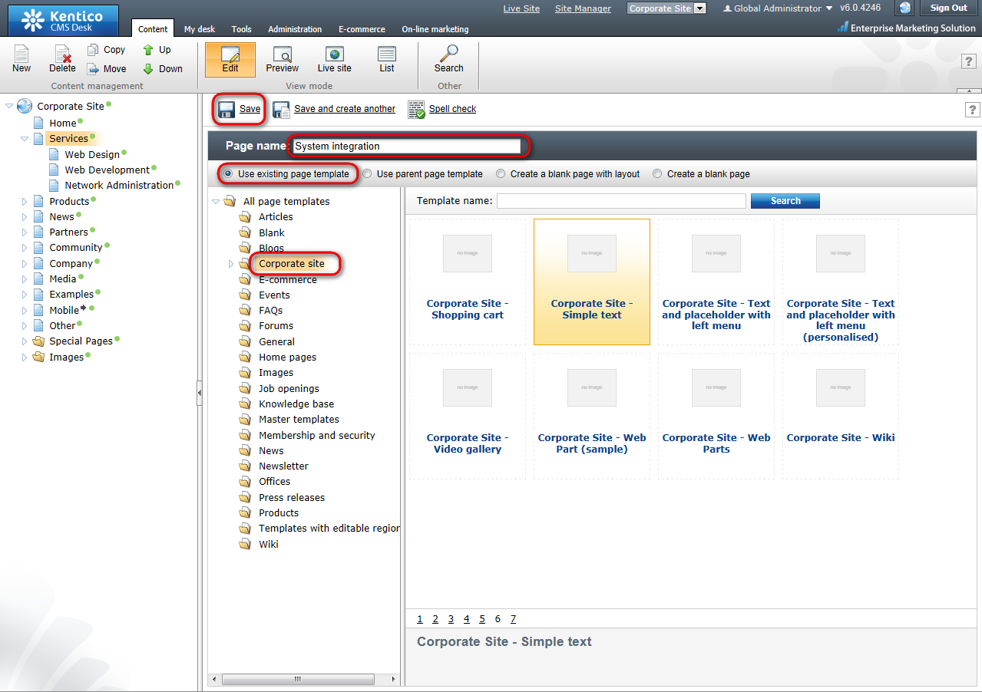
Now you can see your System integration page added to the content tree under the already existing page.
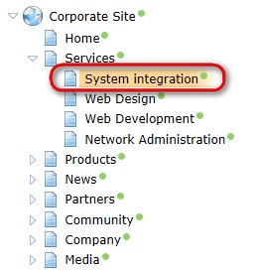
Congratulations, you’ve just created your first web page. In the next chapter, we will add some content to it.

Editing page content

Now we will edit the content of the newly created page.
Click on the System integration page in the content tree on the left side. On the right side in the Editing/viewing space, you can see its content. As we have used the template with two editable regions – header text and content text, we are now able to enter some information into these regions.
Please make sure that the Page tab in the page editing mode toolbar is selected. Only then, you will be able to edit content in the editable regions of your page.
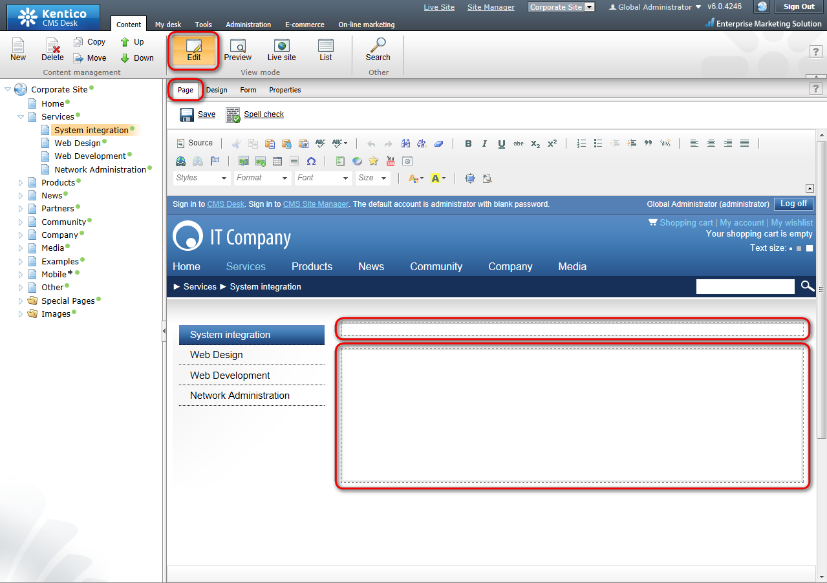

- Place the cursor into the first text box and type in System integration.

- Then enter We provide system integration services in the Editable region box.
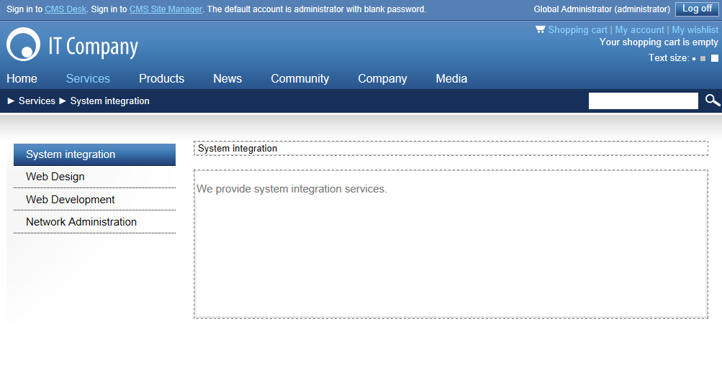
- Click the Save at the top-left and switch to the Live site mode in the page editing mode toolbar. You should see the System integration page with updated content.
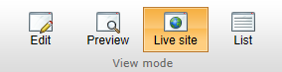
You’ve just entered your first content to your web page.

Using the editor

Using What You See Is What You Get editor

In Kentico CMS, you can use the WYSIWYG (What You See Is What You Get) editor to create web content without HTML knowledge. Its functions are similar to Microsoft Word.
Open your System integration page and choose the Edit mode and click the Page tab so that you could enter content into the editable regions. The WYSIWYG editor toolbar should be visible.
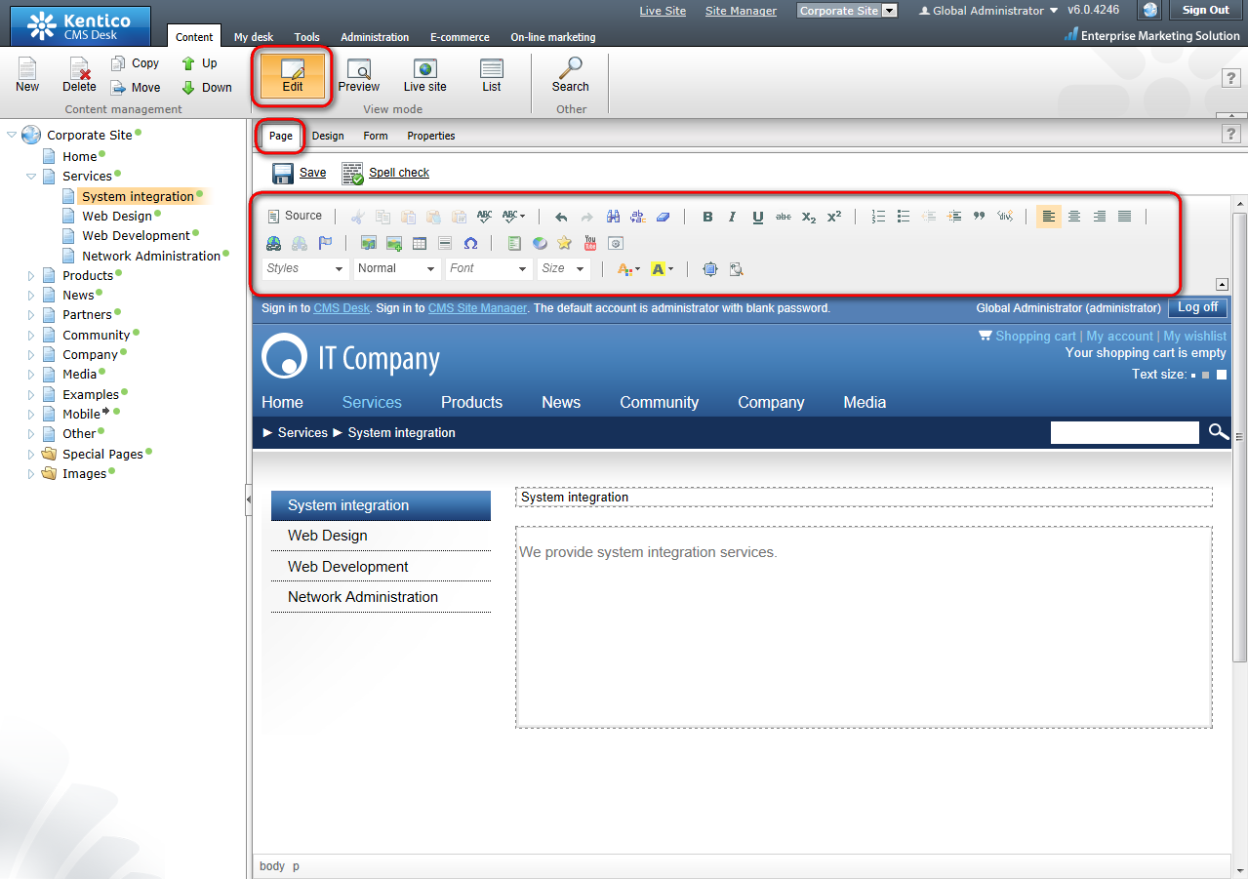

Text formatting

Now let’s take a look at how you can change formatting of your text content.
- Highlight the part of your text you want to change (i.e. System integration).
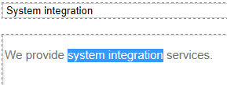
- Now click on Bold sign in the WYSIWYG editor. The highlighted text should change.
- Then highlight another part of the text and change its size by clicking the Size drop-down menu and click the Medium.
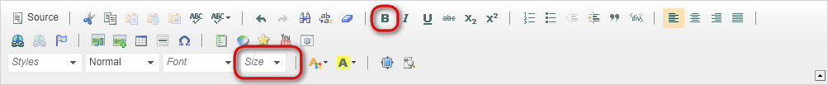
- Now click the Save button at the top.
- Switch to the Live site viewing mode. You should see your text with changed formatting.
That’s how you change formatting of your text.

Inserting images

Very often, you will want to have some pictures on your website. Even for this task, you can use the WYSIWYG editor.
- Choose the page to which you want to insert a picture. Switch in the editing mode and click the Insert/Edit Image or media icon in the WYSIWYG editor.
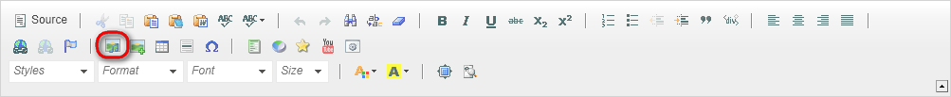
- After clicking the icon, the following dialog will be displayed.
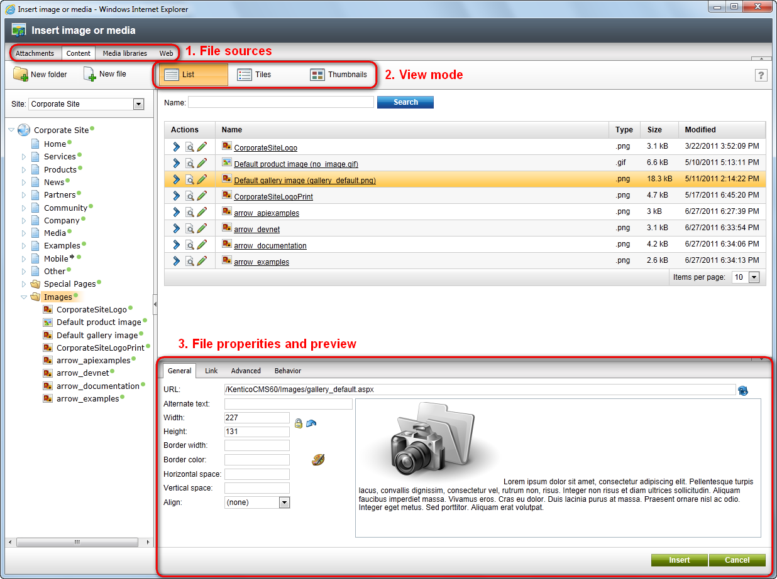
- Choose Content tab, click the Images folder within the content tree. On the right side, you should see the images already uploaded on the server.

- You can choose to use one of these or you can upload another picture from your computer. Click New file at the top to upload a new image on the server to the Content tree.
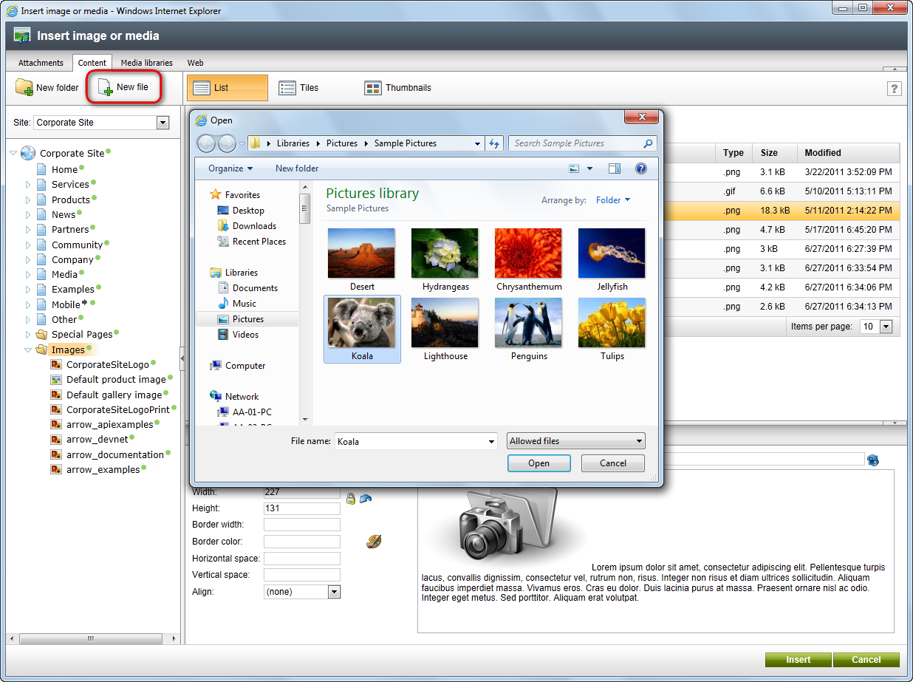
- You will see a preview of the uploaded image. In the Image properties dialog, you can choose the width and height of the picture, its border, vertical and horizontal spacing and alignment. If you don’t need to change anything for now, just click Insert.
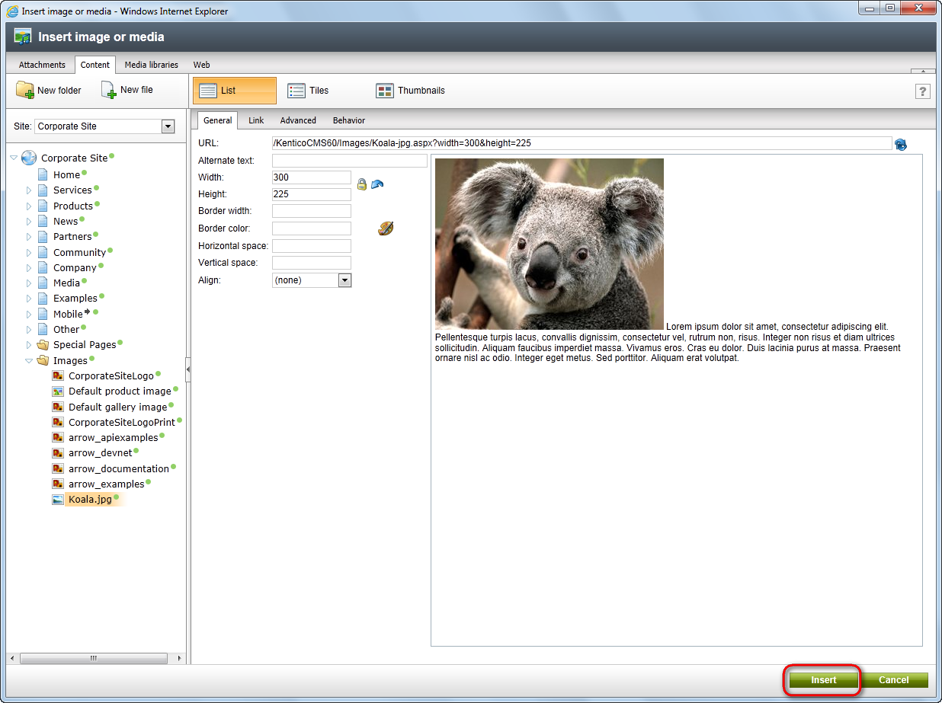
- You should see the picture being pasted in the text. Click Save. Click the Live site button to see the result of your efforts.
In a similar manner, you can upload flash movies to your website.

Creating links

Now you will learn how to add links to your web content.
- In the Page editing mode, highlight the text you want to link to some part of your website.
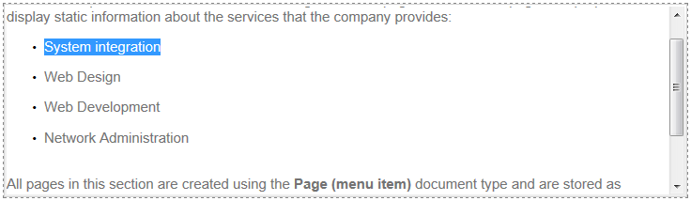
- Click the Insert/Edit Link button in the WYSIWYG editor toolbar.
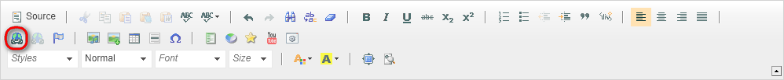
- A new Insert Link dialog opens. All you have to do now is to choose the target page and click Insert. Please note you can choose what target the link should point at. Possible choices are Attachments, Content, Media Libraries, Web, Anchor, E-mail.
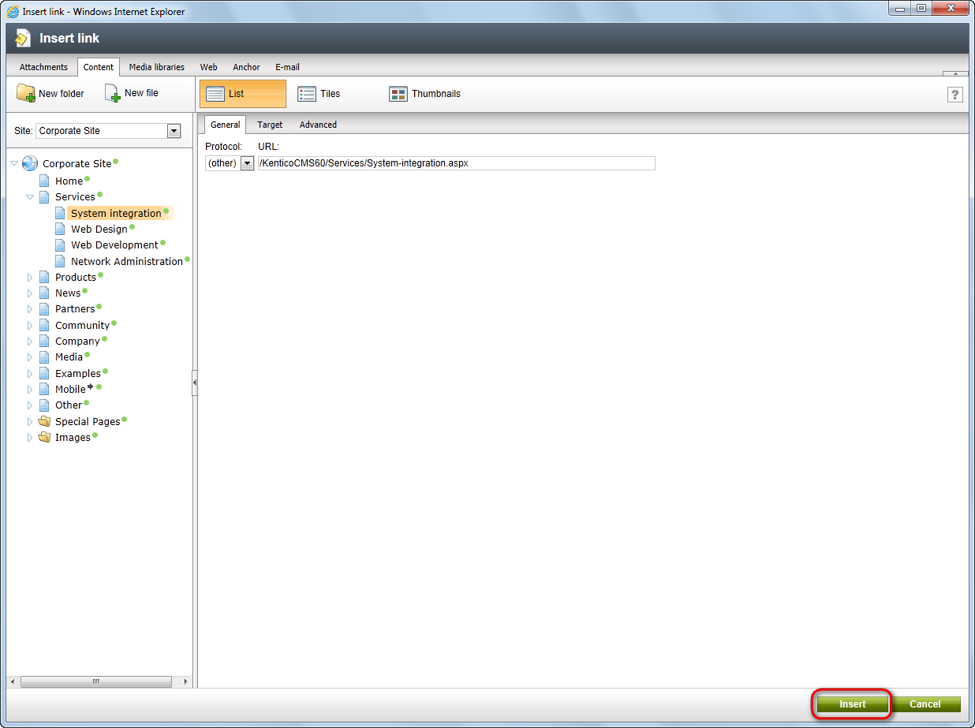

- Click Save on the document and switch to the Live Site mode. Click the newly created link. You should be redirected to the page chosen in the previous step.

Inserting a table

Now you will learn how to add a table to your website.
- Click the Insert/edit table icon in the WYSIWYG editor.
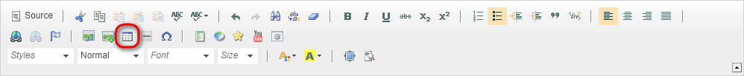
- In the Table properties dialog, change the number rows to 4 and the number of columns to 5. Then enter My table into the Caption field and click OK.
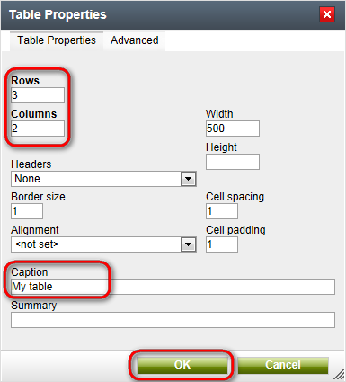
Your table has been added to the web content.

Editing structured documents

Unlike pages with editable regions, structured documents have specific fields that you need to fill in. For example, the news have fields like News title, Release date, News summary and News text. These fields can be edited on the Form tab rather than on the Page tab.

Creating a news item

Now you will learn how to create a news item and add it to the news section.
Please note: Your news item must be added to the section that can show them. In the sample Corporate Site, it is the News page but it may be some other page on your site. Please contact your administrator.
- In the content tree, click the News page and click the New button in the document action toolbar.
- Choose the News document type.
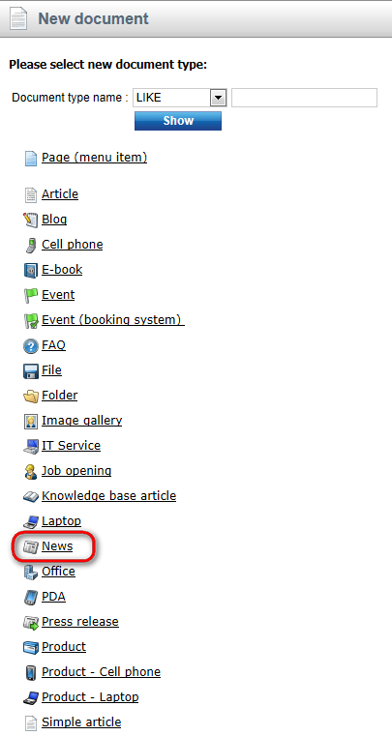
- Now enter the title of your news: My first news. Then click the Now button to fill in the Release date value. In the News summary enter: My first news summary. In the News text enter: My first news text and skip the remaining fields.
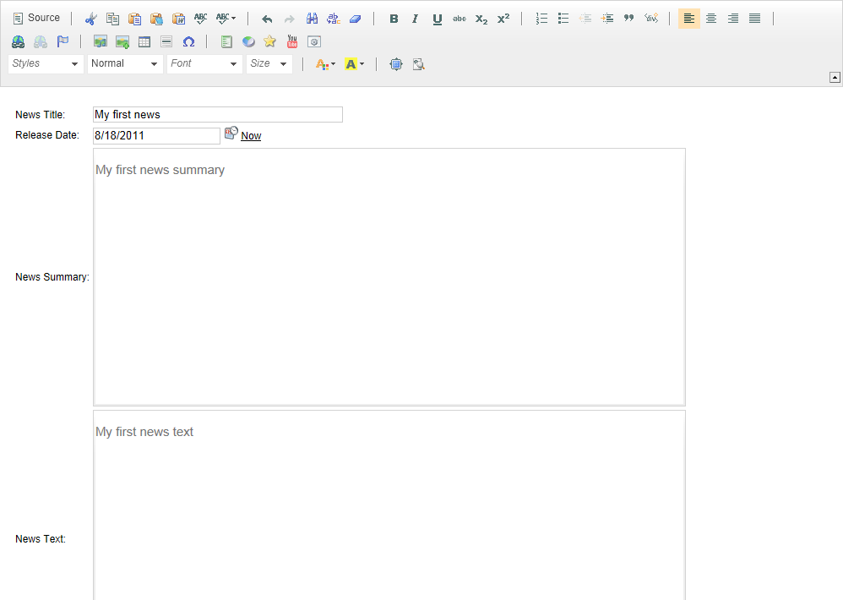
- Now click Save and create another.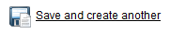
- Enter the title of your news: My second news. Then click the Now button to fill in the Release date value. In the News summary enter: My second news summary. In the News text enter: My second news text and skip the remaining fields. Click Save.
- Now click on the News page in the content tree and switch to the Live Site mode. You can see your two news items added to the news page.
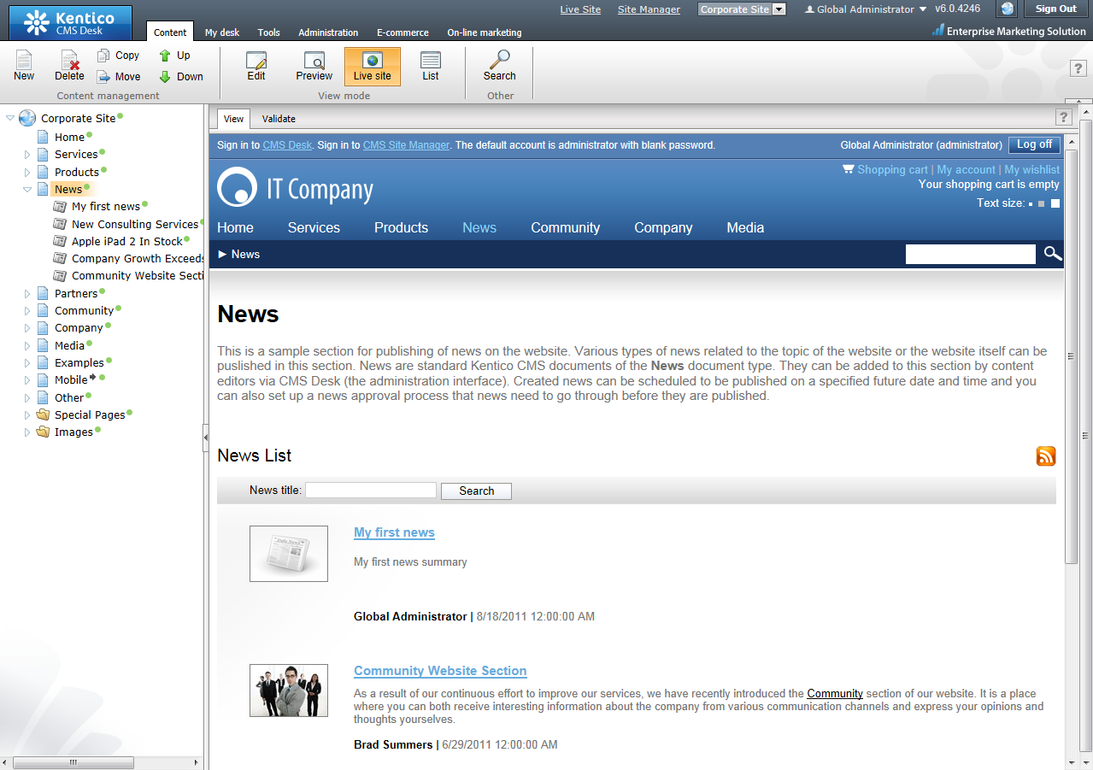
Congratulations, you have just learned how to add a news item.

Editing a news item

Now you will learn how to edit the content of the news item you have just created.
- Click My First news in the content tree and choose the Form tab.
- Change the News Summary text to My first news updated summary. Then change the News Text to My first news updated text and click Save.
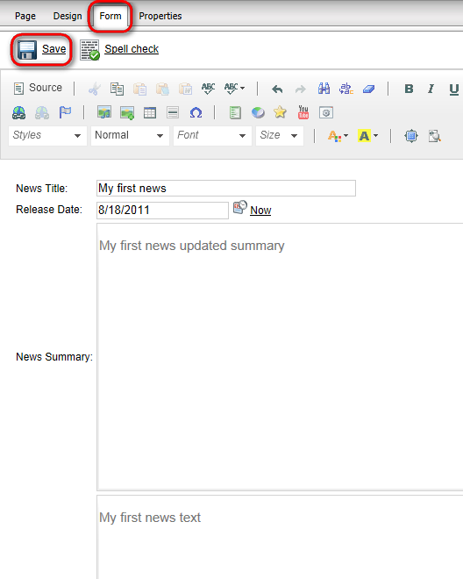
- Switch to the Live site to see your updated news.

Deleting, moving and sorting documents

Deleting and restoring a document

Now you will learn how to delete a document and how to restore it later on.
- Click the My second news item in the content tree. Click the Delete button in the document action toolbar.
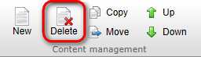
- Make sure that the Destroy document and its history checkbox is NOT checked and click Yes. (You may not see the Destroy document option if you do not have sufficient permissions.)
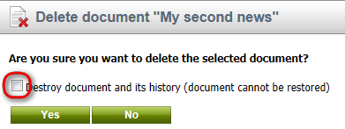

- Now click the My desk tab at the main menu.
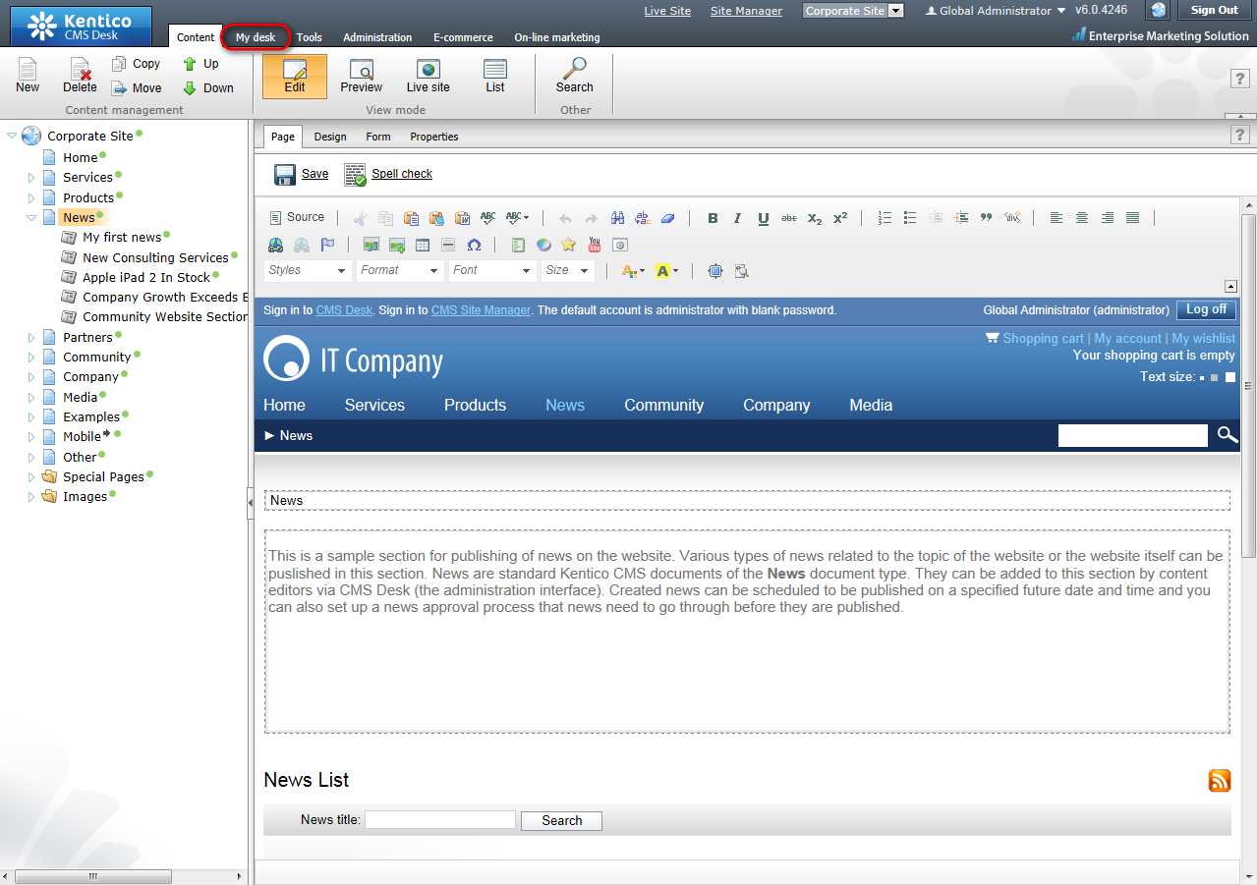
- In the documents section of the ribbon menu at the top, find Bin. Click it and you will see all the deleted documents on the right side.
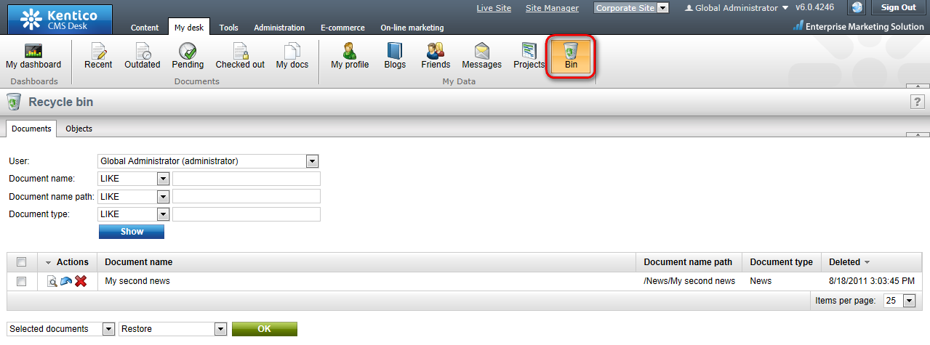
- Find the one you have just deleted and click Restore.
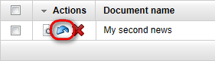
- Now you can switch back to the Content tab and you will see the restored My second news added back to the default location.
Congratulations, you’ve just learned how to delete and restore a document.

Changing document order

Now you will learn how to change the order of a document in the content tree.
- Click the page you want to relocate (e.g. the Services page in the Corporate Site) in the content tree and click the Down button in the document action toolbar. You’ll see that your page has been moved.
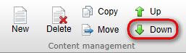
- Now switch to the Live site view mode and you will see that your page has been moved in the main menu as well.

Moving documents to another section

Now, it’s important to realize that the Up and Down buttons in the document action toolbar can be used only to move documents in a one level of the content tree. To move documents to any location in the structure of website you can use the Move button.
- Click the page you want to move in the content tree (e.g. the Services page). Then click the Move button in the document action toolbar.
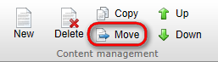
- In the Move document dialog, click on the document where you want to move your page (e.g. the Company section) and then click Move button at the bottom.
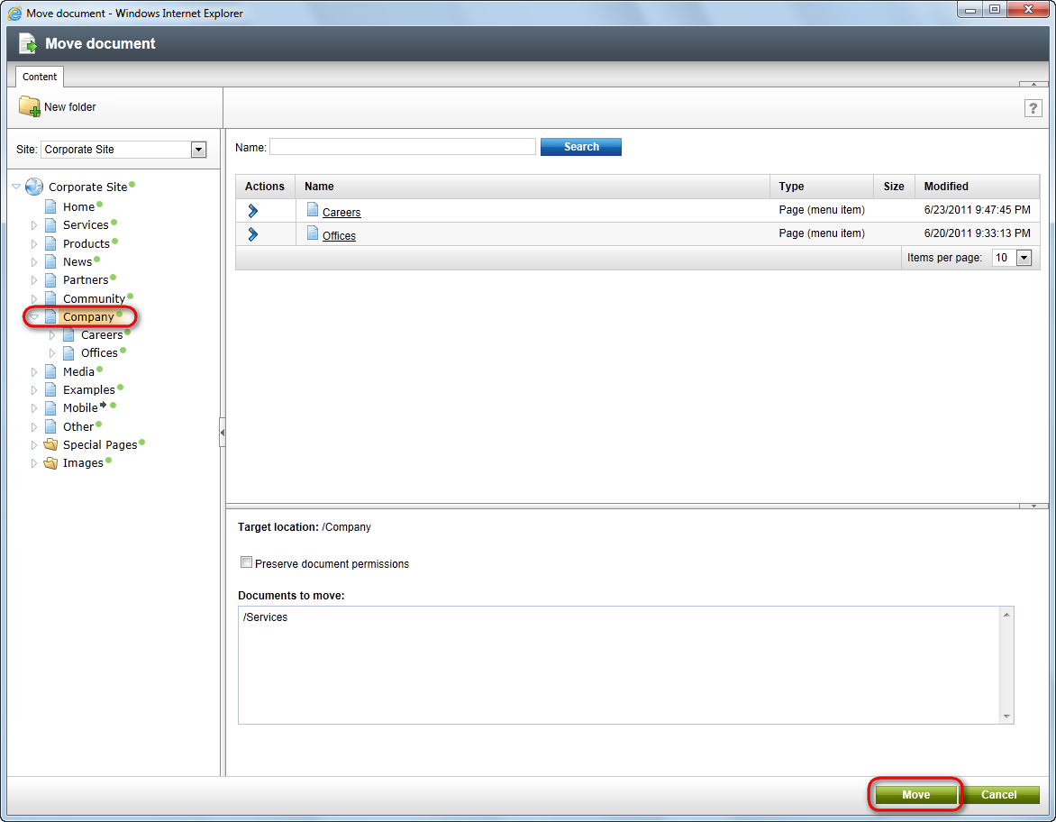
Your page has been moved to the chosen location.

Copying a document

Now you will learn how to copy a document from one place to another.
- Click on the document you want to copy (e.g. the News page) in the content tree and click the Copy button in the document action toolbar.
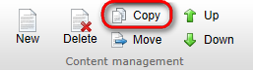

- In the Copy document dialog click on the location where you want to copy your document (e.g. the Company section). If you want to copy all child documents under, please check the Copy also child documents option. Then click the Copy button at the bottom.
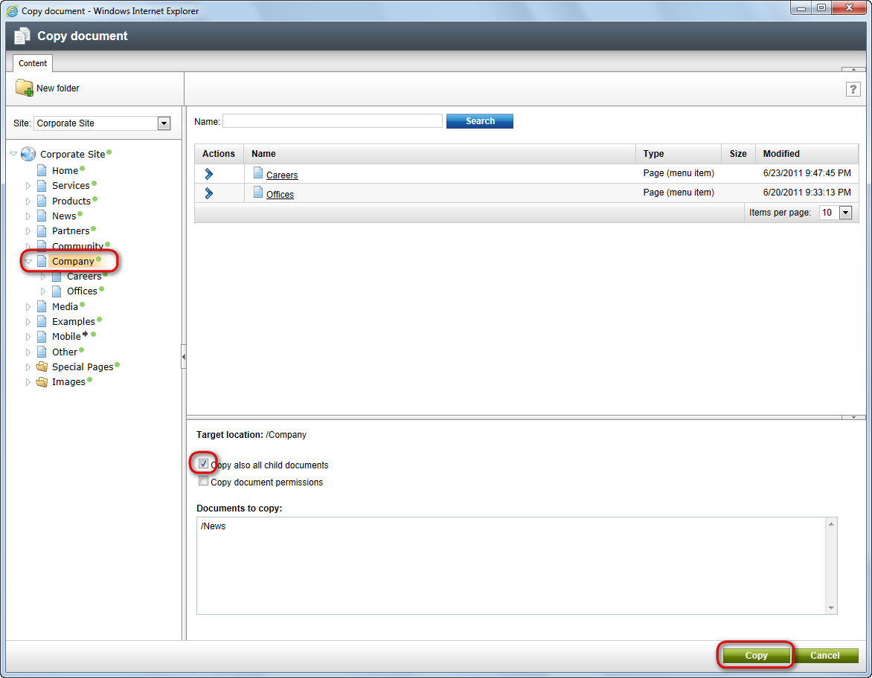
You have just learned how to copy a document.

Translating documents

You might want to have your website in multiple languages so that your website would be useful for many visitors with different cultural backgrounds.
Please note: For this part of the guide, your website has to be configured for multiple language versions. You should see the language option drop-down menu or the flag selector in the language toolbar (when there are more than 5 cultures, you’ll see rather drop-down list). If you cannot see it, please contact your administrator to configure multilingual support for you.
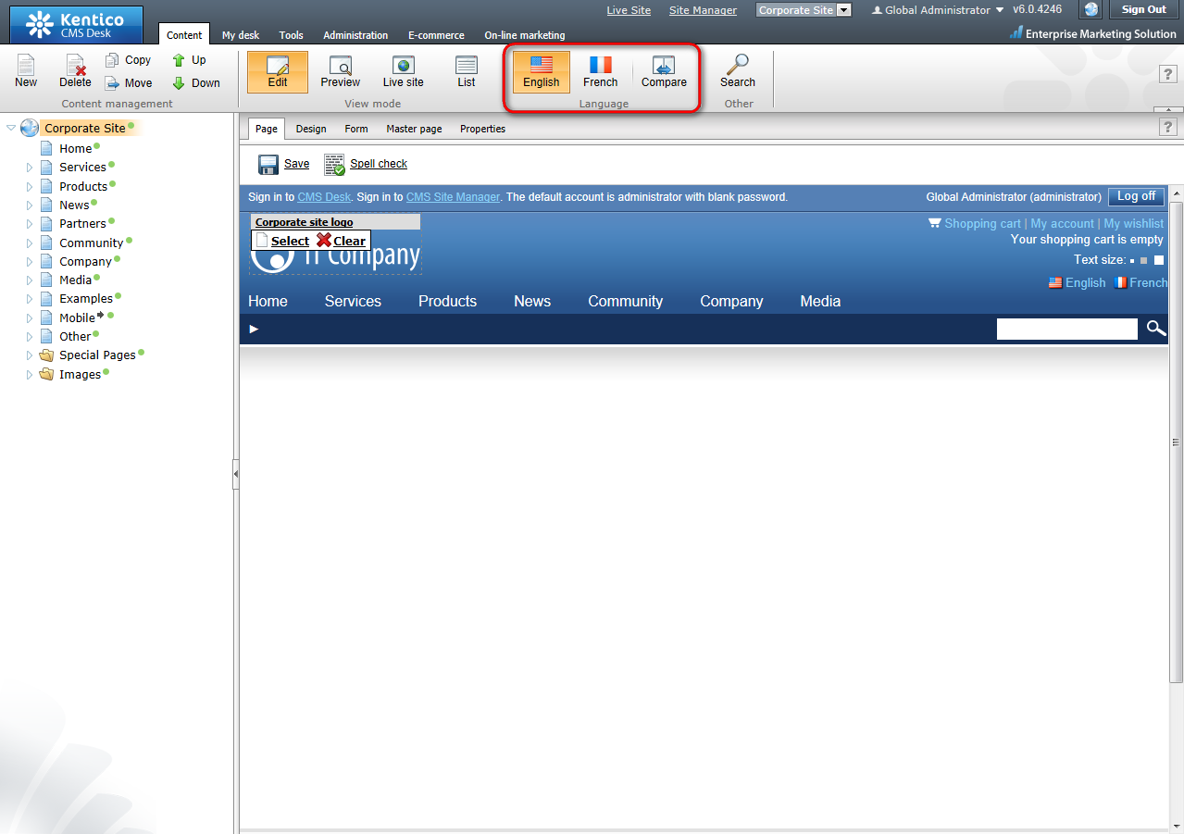
- Make sure you are in the editing mode and choose from the Language drop-down menu (flag selector) the language to which you want to translate your documents.
- In the content tree, click one of documents with a little cross next to it. The cross icon indicates the document hasn’t been translated yet.
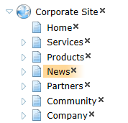
- You will be displayed with dialog for creating a translated version of the document. In the following option, choose the Copy content from another language option and select from which language version you want your document to be copied. Then click the Create document button.
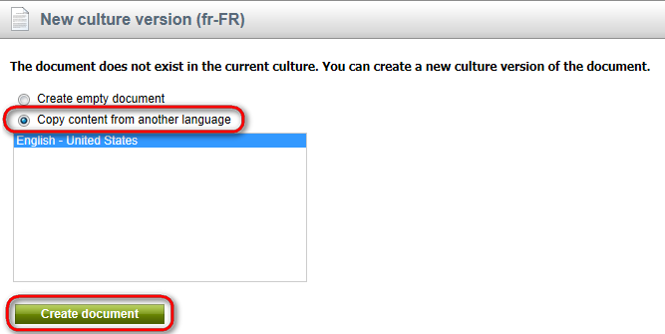

- In the Document name field enter the translated title of your page. Click Save.
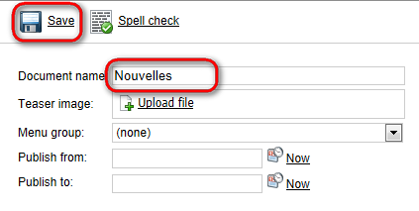
- Now you can switch to the Page editing mode and start translating the content of your page. Please note, you will need to translate the master page (Root document) the same way to see whole content of the page.

Congratulations, you have just learned how to translate a document to another language.

Workflow and versioning

Please note: for the Workflow tutorial, we assume that your website has been configured for workflow. For more information please contact your administrator or consult the Kentico CMS Developer’s guide.

Publishing a document

Please note: for this part of the user’s guide, we use an example with three default workflow steps – edit, publish, archive. Your website might use different workflow steps. However, the procedure will be the same.
- In the content tree on the left side, choose the document you want to edit. At the top of the editing/viewing space, there is a bar indicating your current Workflow step: Edit.
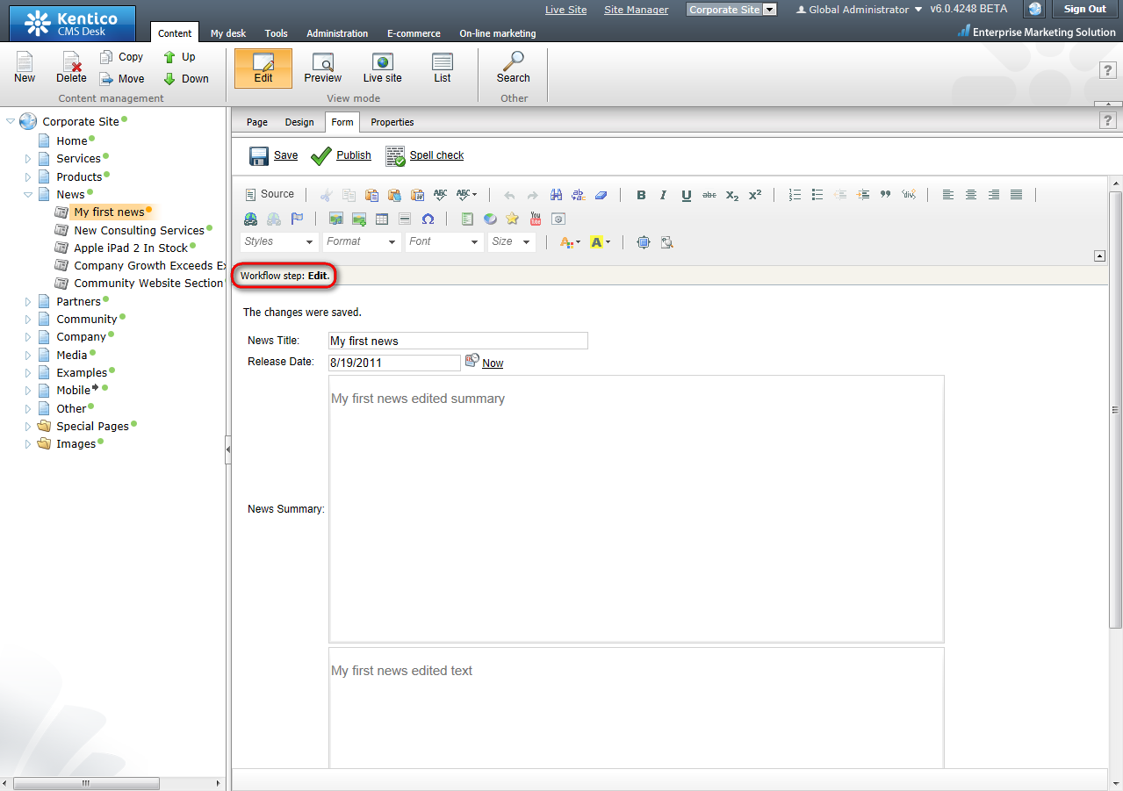
- Edit the content of your page and click Save.
- Now switch to the Preview viewing mode. You can see your page updated. However, you won’t see your changes in the Live site viewing mode so far because your updated page has not been published yet and it’s still in the Edit workflow step.
- Click the Publish icon.
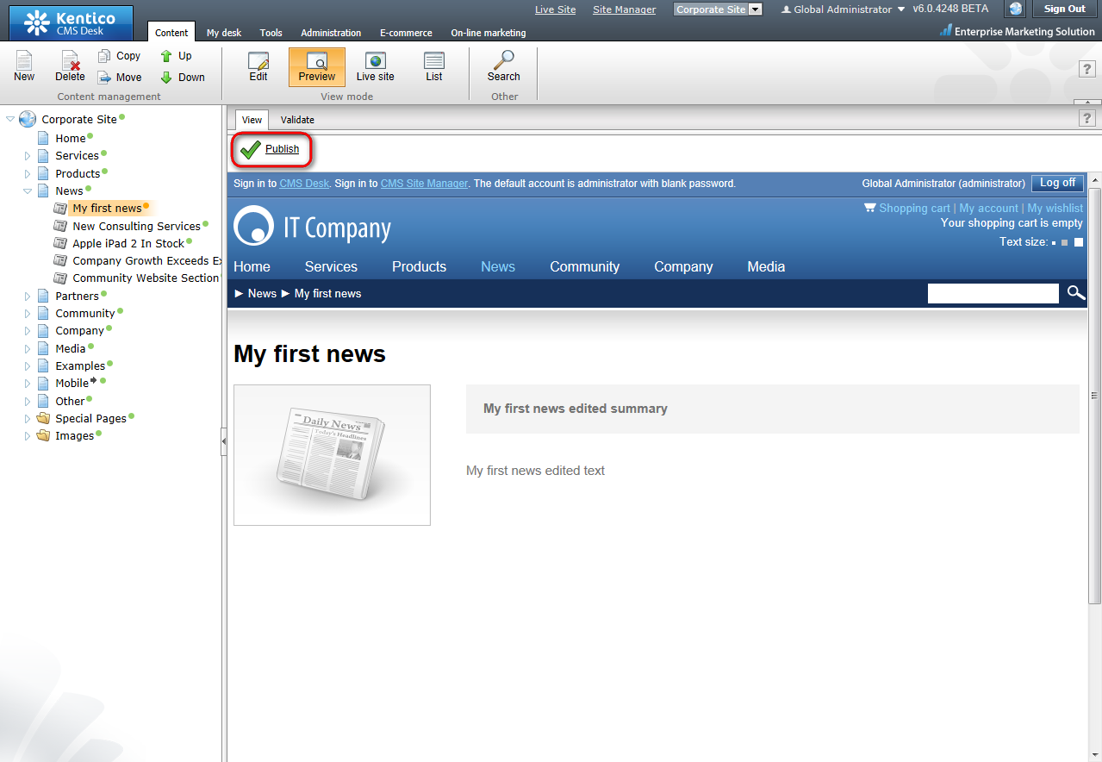
- Now switch to the Live site. Your edited page has been published and is now visible on your real website.
That’s how you get your document through the workflow steps to be published.

Archiving a document

You can use the Kentico CMS to archive a document from your website. It won’t be visible to visitors but it will be stored in a database ready to be posted again any time you need.
- In the content tree, click on the document you want to archive and choose the Edit viewing mode. Click the Properties tab.

- In the vertical menu on the left, switch to the Workflow tab.
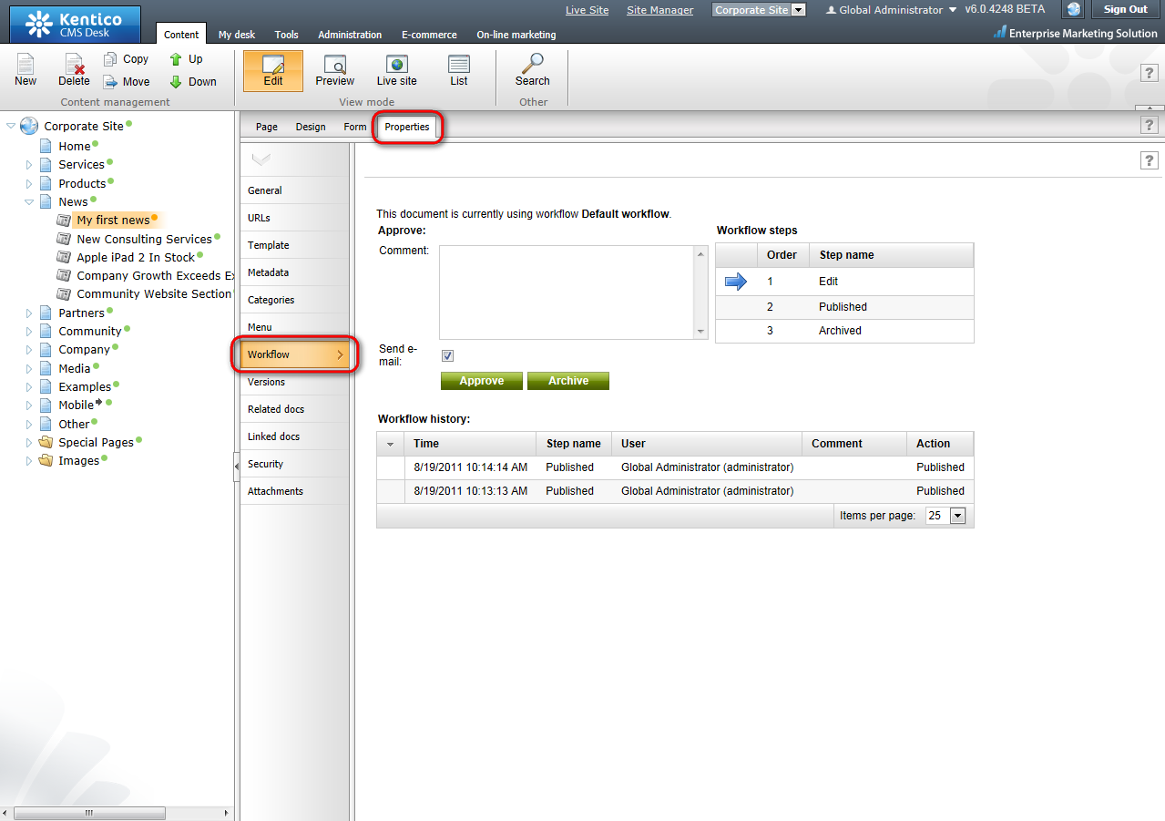
- Now click the Archive button.
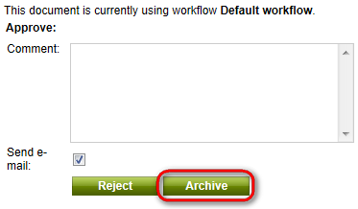
That’s how your document is withdrawn from the website and stored in the archive.

Versioning and rollback

Please note: Versioning and rollback work only for documents that use workflow.
You may want to list through previous versions of your document and choose one of the older versions to be published on the website. For that you can use Kentico CMS versioning and rollback.
- In the content tree, click on the document you want to change. Make sure you are in the Edit viewing mode and go to the Properties -> Versions.
- On the right side, you can see the list of versions of the document.
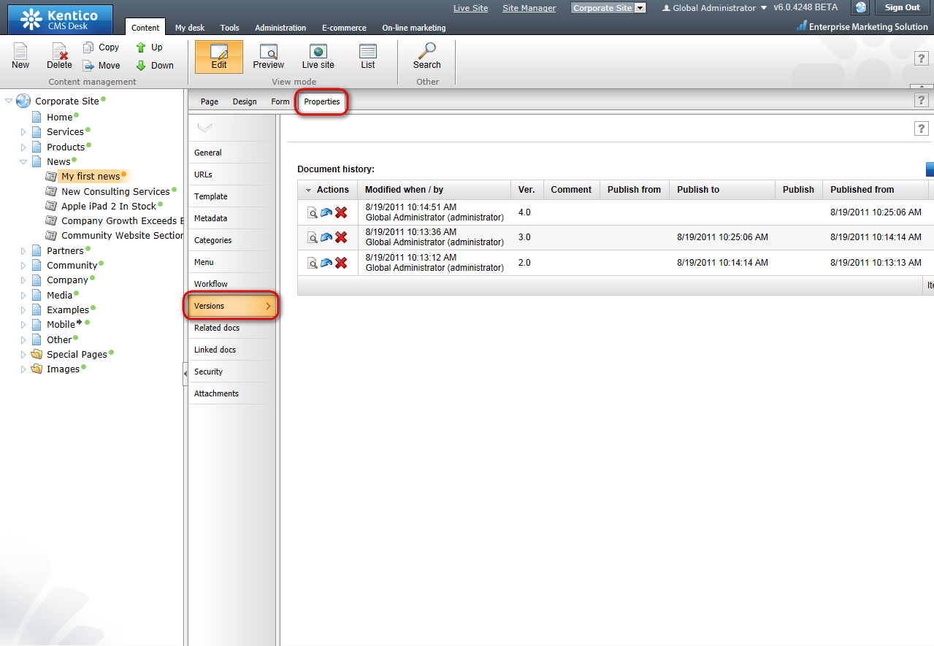
- Choose the version you want to publish and click the Rollback version button.
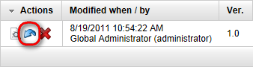
- Click OK to return to the selected version of the document.
- Now switch to the Workflow tab in the vertical menu. You will see that the restored version of the document is in the workflow step Edit. You need to publish it again to be visible on the live site.
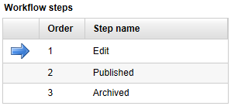
- Switch to the Page editing mode and click Publish.
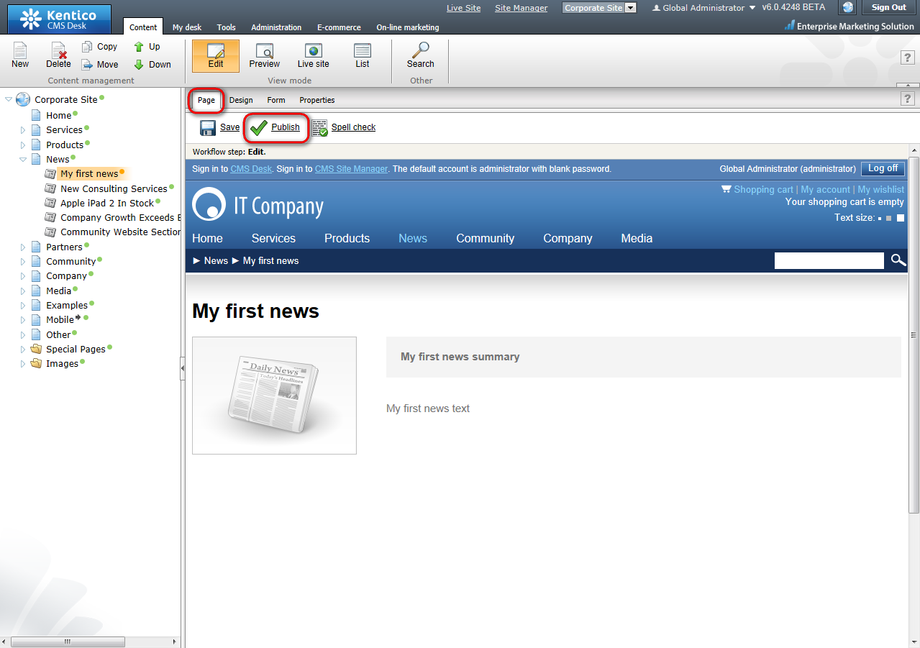
- Now switch to the Live site viewing mode.
Congratulations, you have successfully rolled back to the older version of your document and you have published it on your website.

Security

Granting permission to edit a document

Please note: For this part of the tutorial, you have to be a user with the access rights for granting permissions to other users.
For more information about security in Kentico CMS please consult the Developer’s Guide.
- In the content tree, choose the document to change its security settings.
- Make sure you are in the Edit viewing mode and go to Properties -> Security.
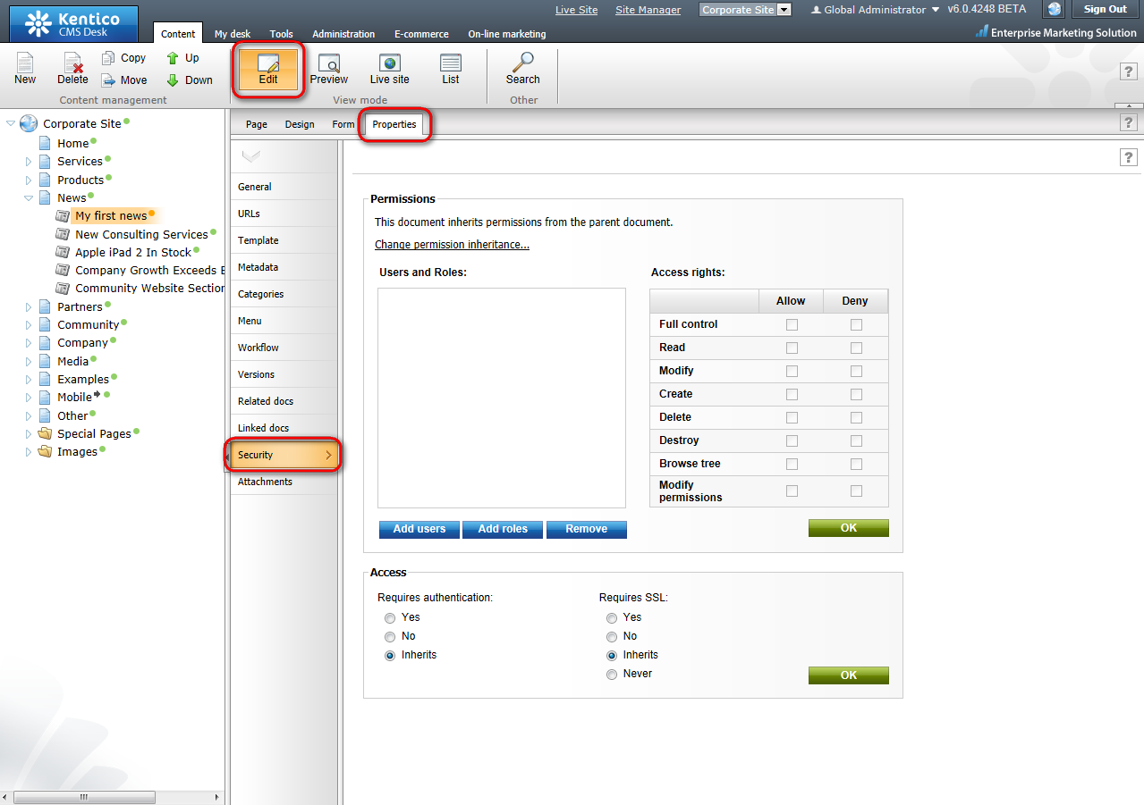

- Click Add roles button.
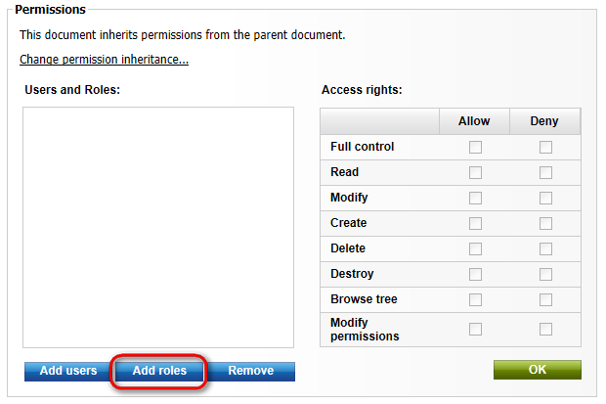
- In the Select roles dialog choose CMS Editor. Then, click OK.
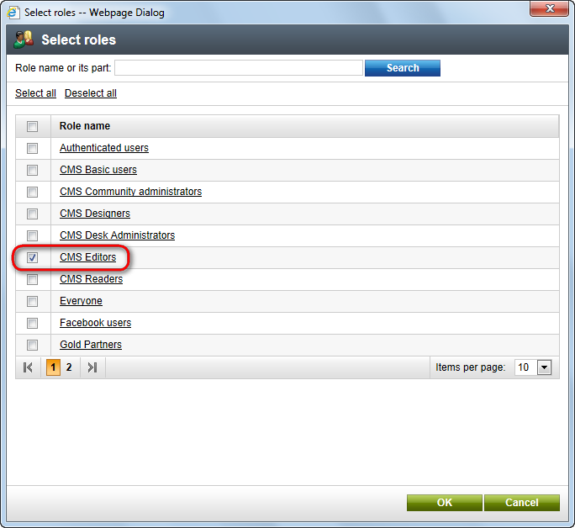
- The role CMS Editors has been added to the list. Now click the Allow checkboxes in the Read, Modify and Create line. Then click OK.
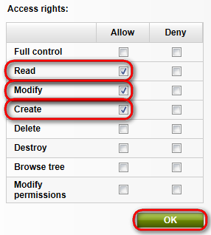
Congratulations, you’ve just granted editing rights to the CMS editors role for the given document. Please note that you can also set permissions just for particular users this way.

Newsletters

You might want to send your customers e-mail newsletters to inform them about your new products. In Kentico CMS, you can create your e-mail newsletters in a manner of minutes.

Creating a newsletter issue

- At the main menu, switch to the Tools tab, choose Newsletters in the ribbon menu, switch to Newsletters tab and click Edit next to the existing newsletter (e.g. Corporate Newsletter).
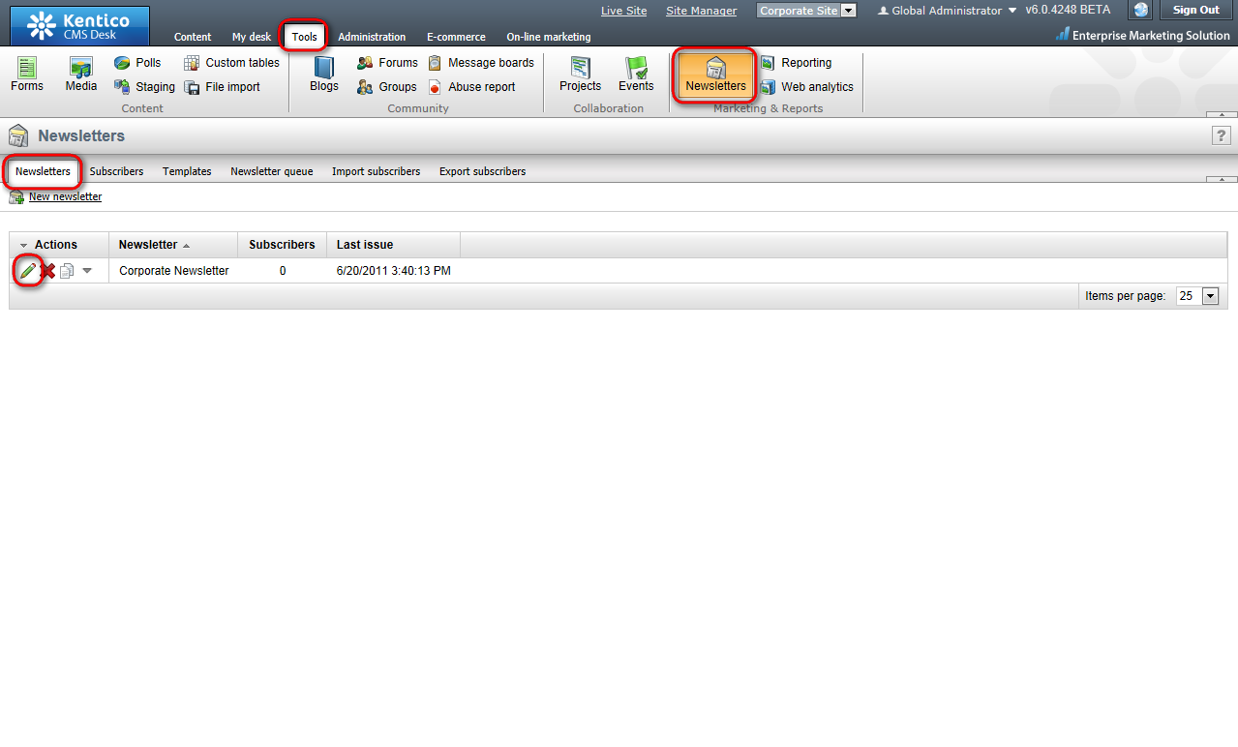

- In the Issues tab, click Create new issue. A new issue wizard appears. It will guide you step by step through the process of creating the new issue.
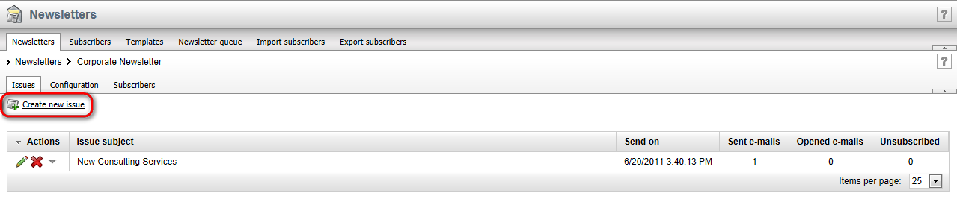
- In the first step of the wizard, enter My newsletter issue into the Subject textbox. Check the Show in newsletter archive checkbox and enter The content of my newsletter issue into the Content textbox (Please note that for editing the content of the issue, you can use the WYSIWYG editor). Then click Save button at the bottom. You might need to scroll down a little bit to see it.
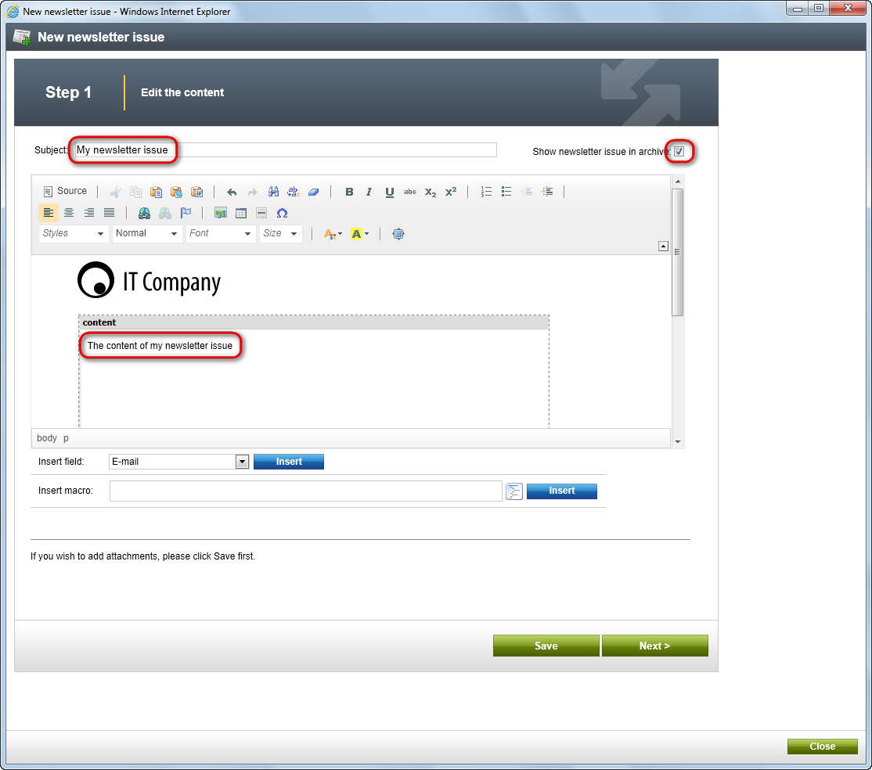

- The issue has been saved. Now click the Next button at the bottom next to the Save button.
- In the step 2, click Next again.
- In the step 3, make sure the Send now option is chosen and click Finish at the bottom.
Your new newsletter issue has been send to the subscribers.

Please note that sending of e-mails with a new newsletter issue may take some time. Switch to the Newsletter queue tab to check the status of your e-mails.
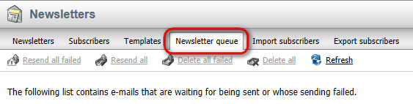

Forms

Creating and publishing a new on-line form

- Go to Tools -> Forms. Click on New form.
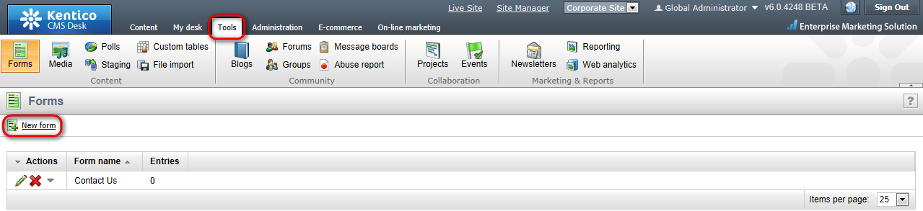
- Enter:
- Form display name: Send us a message
- Form code name: SendMessage
- Table name: Form_CorporateSite_Messages
Then click OK.
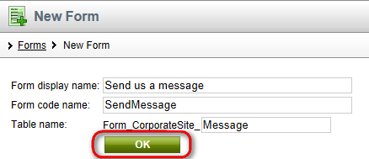
- Switch to the Fields tab and click New attribute.
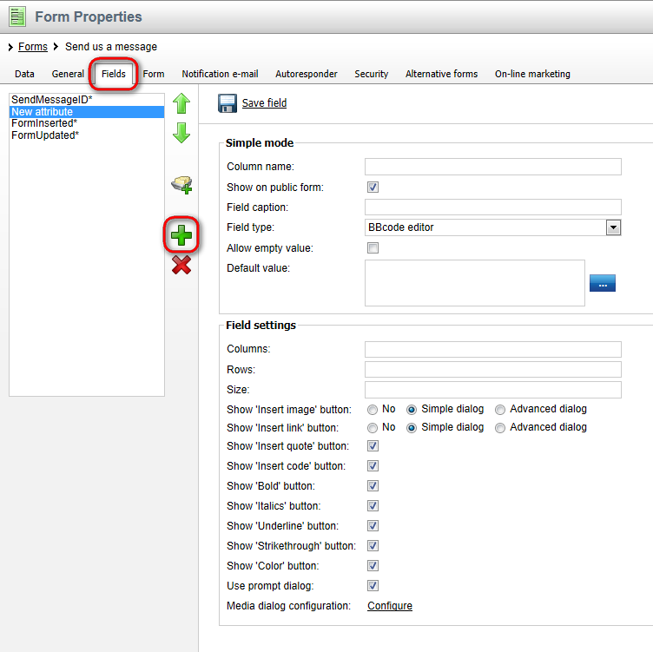
- Enter the following information:
- Column name: FirstName
- Field caption: Enter your first name
- Field type: Text box
- Maximum length: 15
Click Save field.
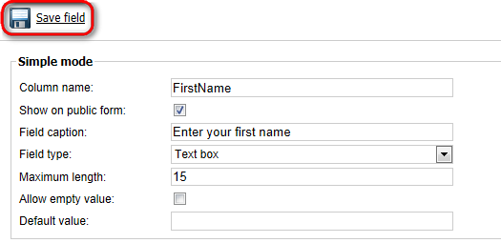

- Click New attribute again and enter:
- Column name: LastName
- Field caption: Enter your last name
- Field type: Text box
- Maximum length: 20
Then click Save field.

- Now click New attribute again to add another column. Enter:
- Column name: Email
- Field caption: Enter your e-mail address
- Field type: E-mail
- Maximum length: 40
Click Save field.

- Click New attribute again to add the last column. Enter:
- Column name: Text
- Field caption: Enter your message
- Field type: Text area
- Maximum length: 1000
Click Save field.
- Your form is ready to be published on your website. On the main menu, switch to the Content tab and choose the System integration page in the content tree.
- In the Page editing mode, place the cursor inside the second Editable region and click the Insert Form button in the WYSIWYG editor.
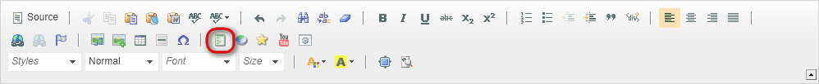
- In the displayed web dialog, click Select next to the Form name field and choose the Send us a message form. Then click OK.
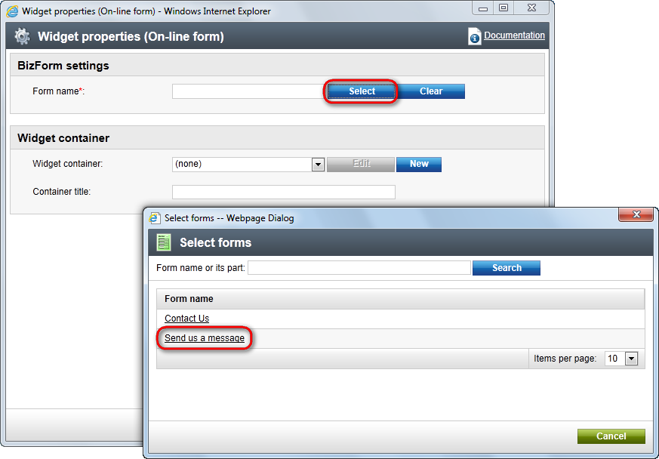

- Now, click Save and switch to the Preview mode. You can see that your form has been added to the System Integration page.
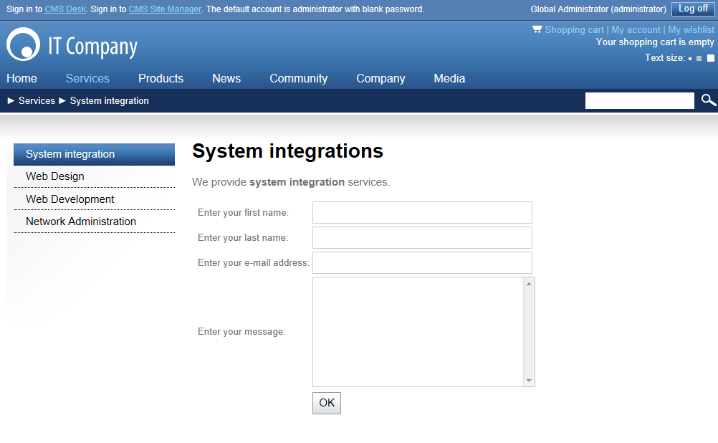
After the form is submitted, you can find the form data in CMS Desk -> Tools -> Forms -> Edit (Your_Form) -> Data. You can set an e-mail notification as well at CMS Desk -> Tools -> Forms -> Edit (Your_Form) -> Notification e-mail.
Congratulations, you’ve just gone through the process of creating a brand new form for your website.

E-commerce

Creating a new product

Now you will learn how to create a new product for your e-commerce.
- In the content tree, choose Products -> Smartphones and click New in the document action toolbar.
- Select the Smartphone document type.
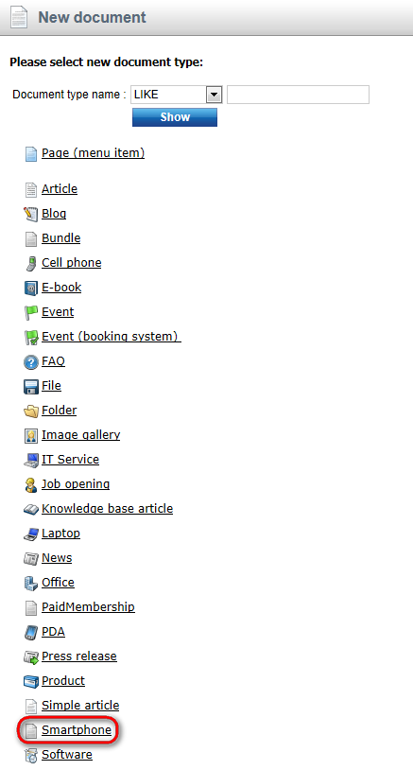

- In the Form tab, enter:
- Name: HTC Evo 3D
- Operating system: Android 2.3 Gingerbread
- Dimensions: 127 x 66 x 11.3 mm
- Weight: 170 g
- Display type: Super-LCD
- Display size: 4.3"
- Display resolution: 960x540
- CPU: Qualcomm Snapdragon Dual-Core 1.2 GHz
- RAM: 1 GB
- Internal storage: 4 GB
- Removable storage: 8 GB Micro-SDHC (expandable up to 32 GB)
- Battery type: Li-ion 1730 mAh
- Camera: Dual 5 MP
- GPS: YES
Then check the Create a new product check box and enter 900 as Price. You can upload Product image if you want to. Choose Smartphones within the Department drop-down list. Click Save at the top. Your new product has been created.
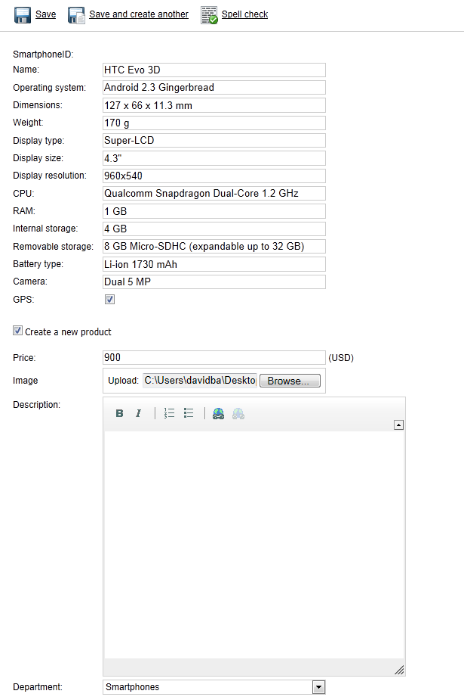
- Now go to Product -> Tax classes. Here you can apply the chosen tax to the new product. Click Add tax classes button, choose the Sales tax and click OK to save the changes again.
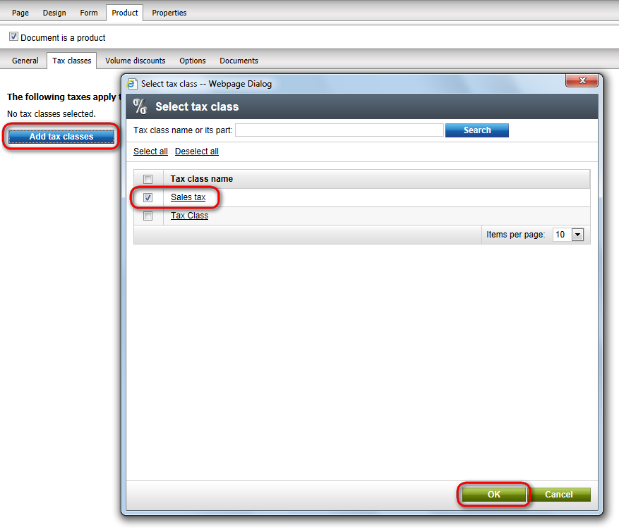
- Switch to the Volume discounts tab and click New volume discount.
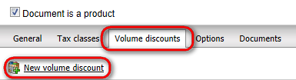
- Enter 10 in the Minimum amount textbox. Choose the Relative discount radio button and enter 5 in the Discount value textbox (this will add the 5% discount to the product price.). Click OK and close the dialog.
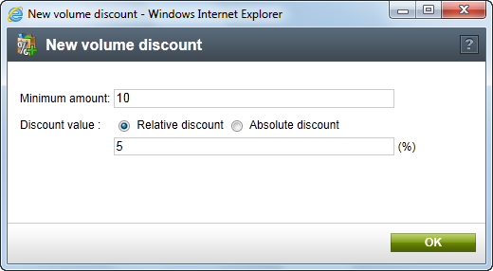
- In the content tree, choose the Smartphones page. You can see your new product has been successfully added to your e-commerce website.
Congratulations, you’ve just learned how to create a new product.

Changing order status

Now you will learn how to change the status of your order.
Firstly you have to make an order to be able to change its status.
- Open your favorite internet browser, go to the Corporate site and choose Products -> Smartphones in the main menu.
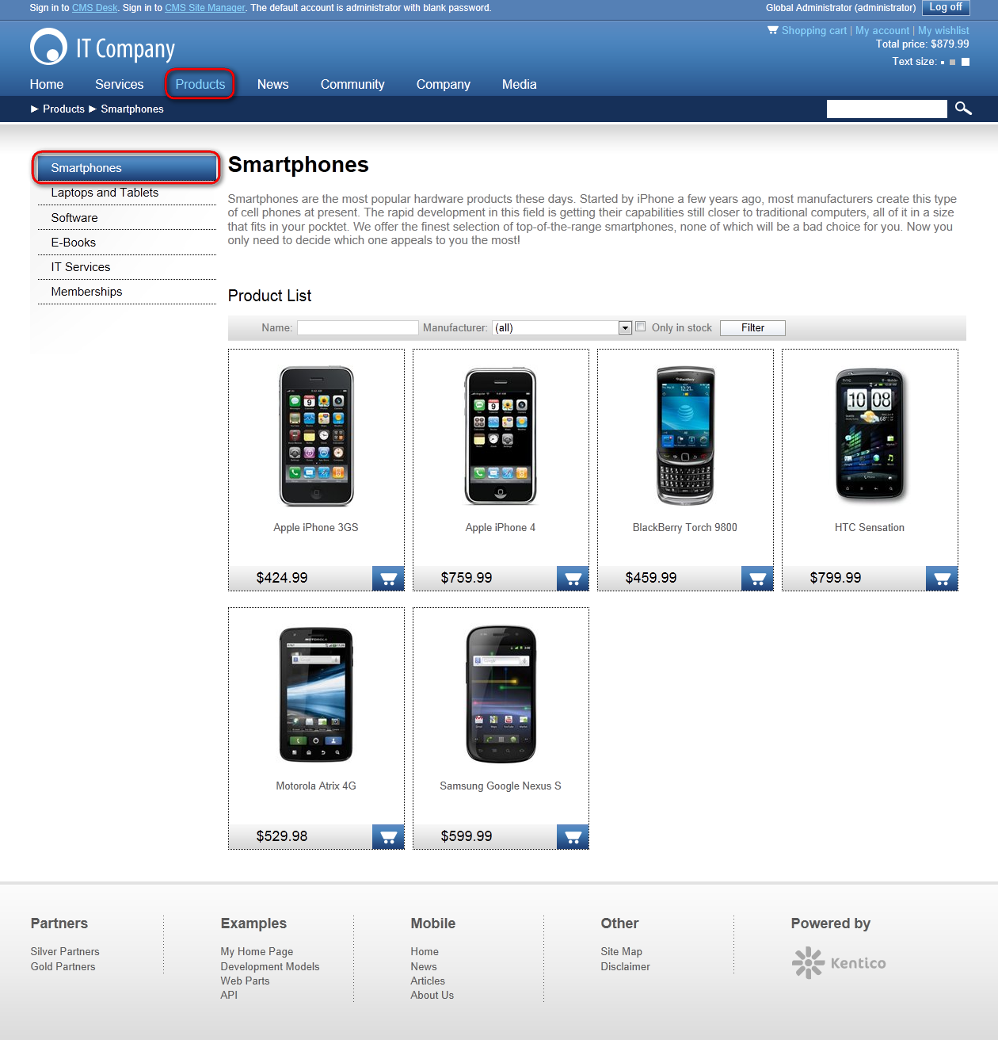

- Click the Add to shopping cart button below HTC Sensation
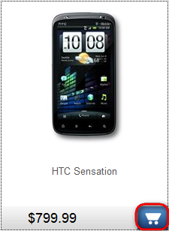

- In the Step 1 of the check out process, click the Check out button at the bottom.

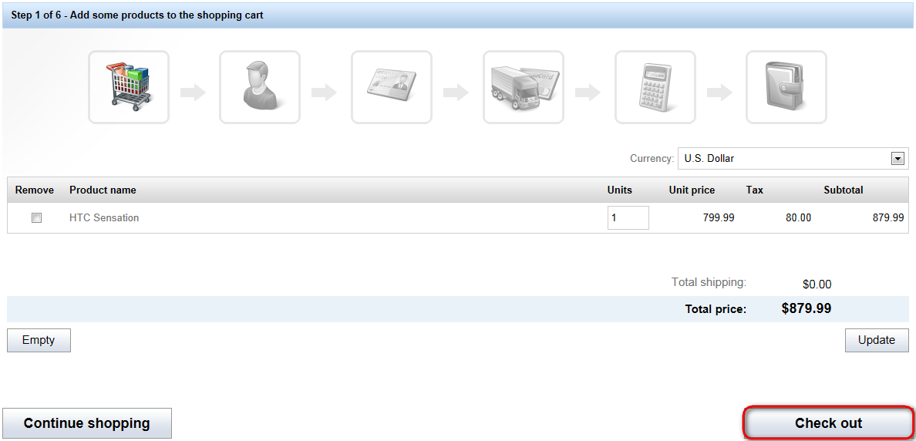

- In the Step 2, choose Create a new account and enter following information:
- First name: John
- Last name: Smith
- E-mail (user name): johnsmith@localhost.local
- Password/ Confirm password: johnsmith1
Then click Next.

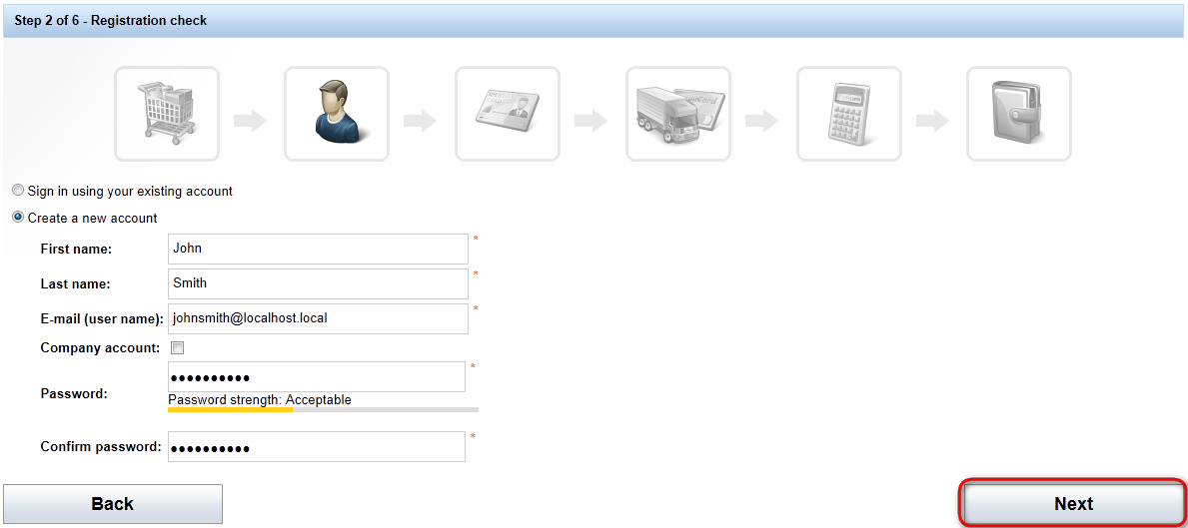

- In the Step 3, enter following information:
- Name (company or personal): Software Development
- Address lines: 1020 Blueberry Ln.
- City: Tucson
- ZIP: 85474
Then click Next.
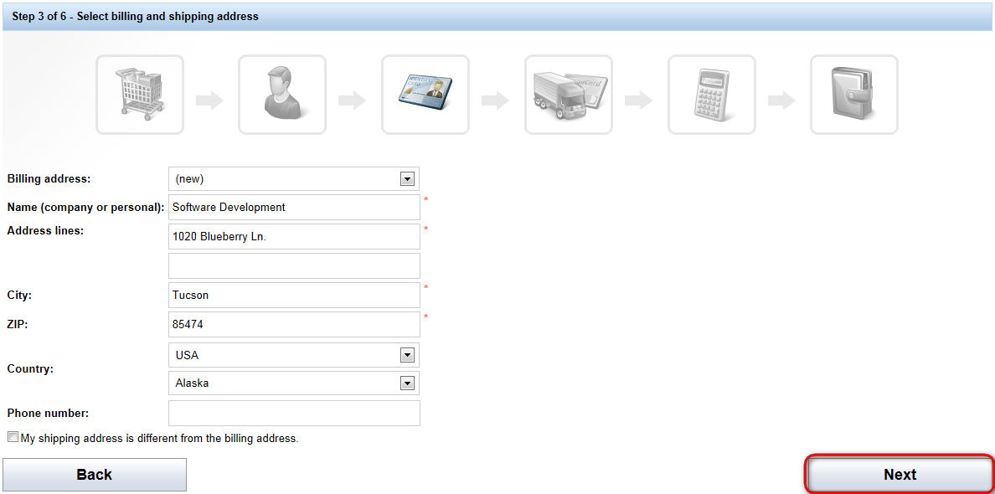
- In the Step 4, do not change anything and click Next.
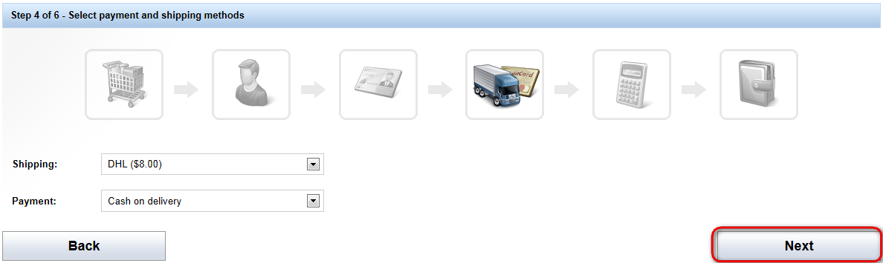

- In the Step 5, click Order now.
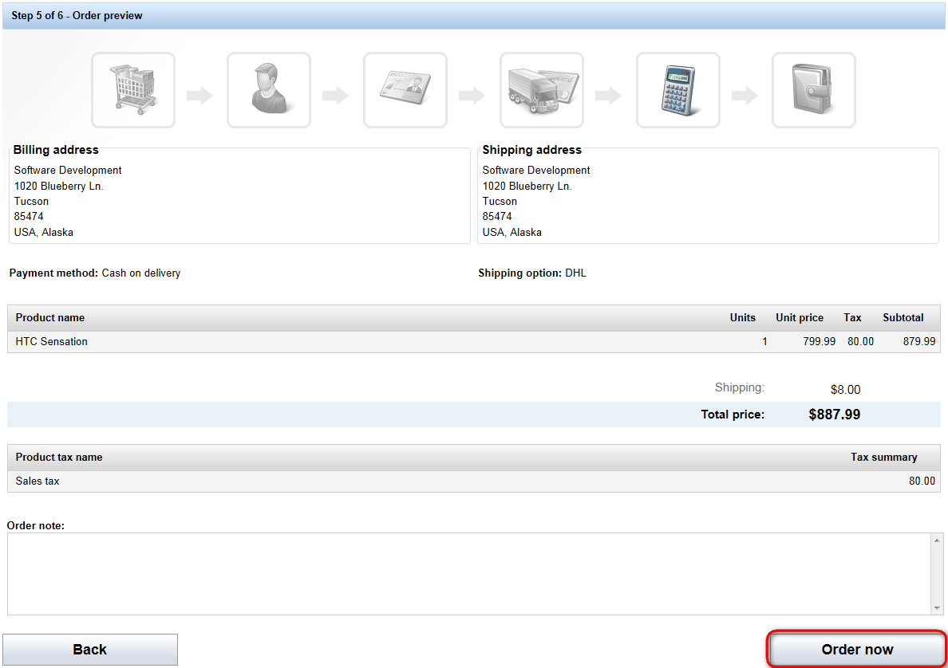

- You should see the order confirmation text now. Your order has been received. Now sign in to the CMS Desk and go to E-commerce -> Orders.
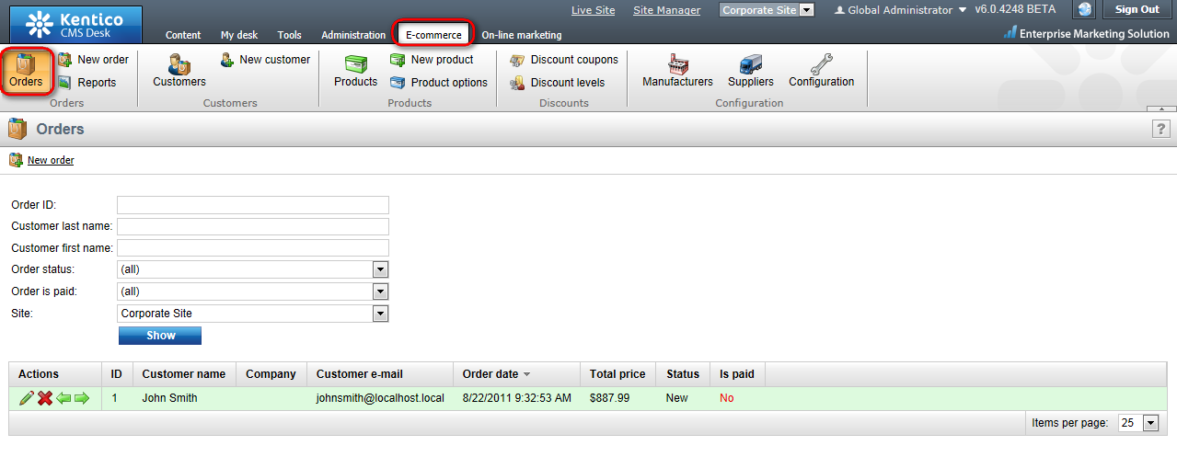
- Click Edit next to the newly created order.
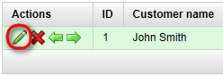
- In the General tab, choose Payment received from the Status the drop down menu and click OK.
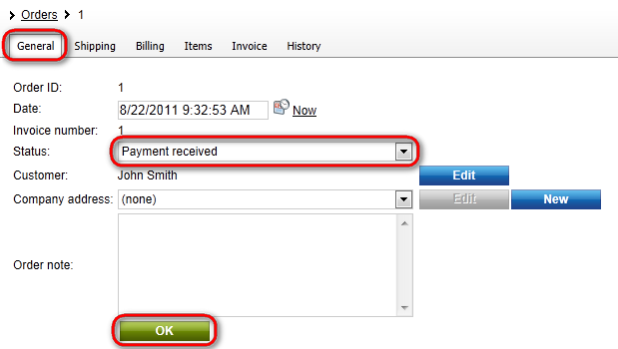
The status of your order has been changed successfully.

File import

Bulk import of files

Now you will learn how to import files and documents to your website.
- Go to Tools -> File import.
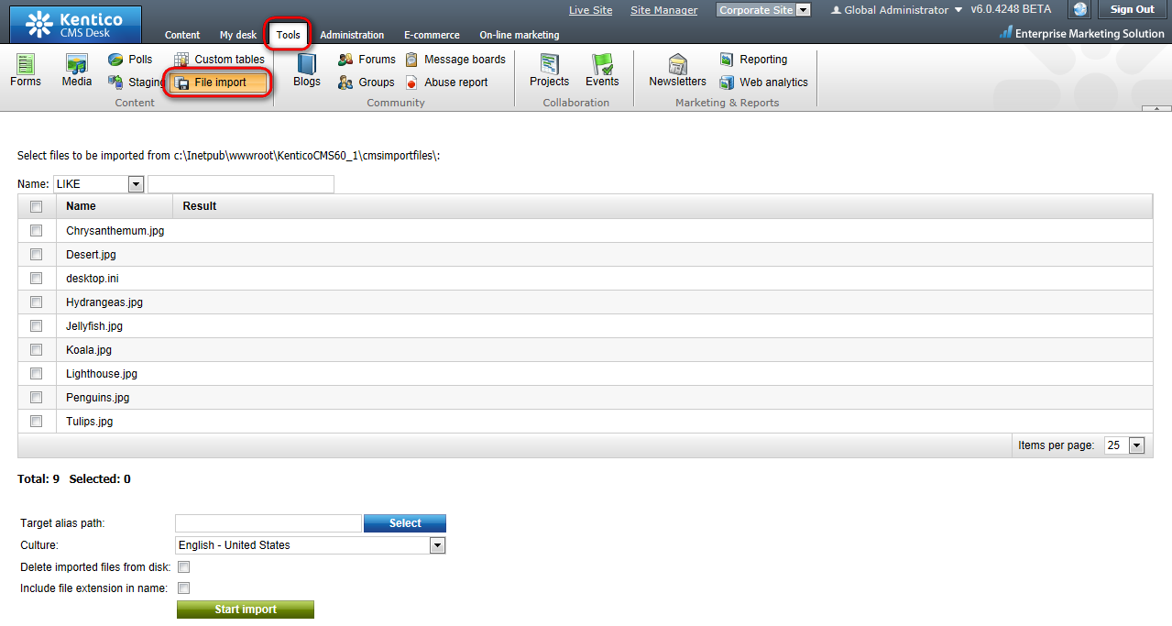
- On the right side, you should see the files from the folder designated as the source for the file import. If you can’t see any that means there are no files in your file import folder. Please check the path to the file import folder at the top and place the files you want to upload to that folder.

- Check the Select checkbox next to the file you want to import and click Select.
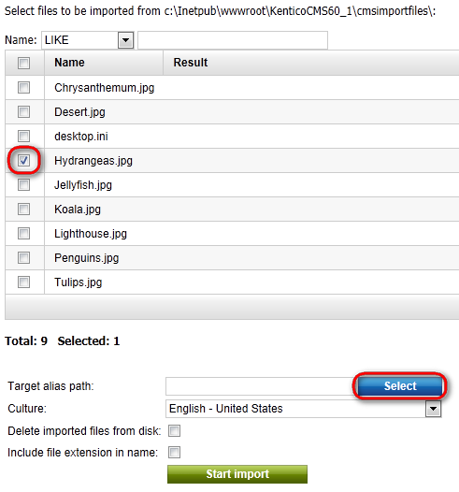
- Choose Examples and click the Select button.
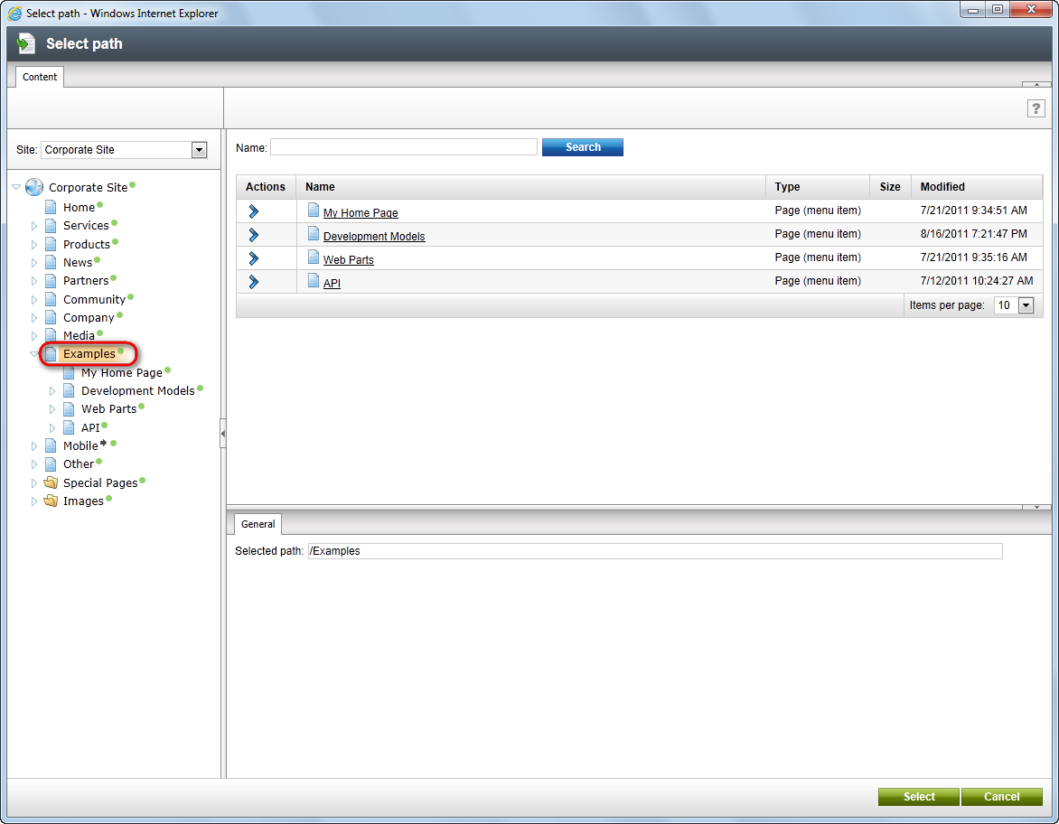

- Click Start import.
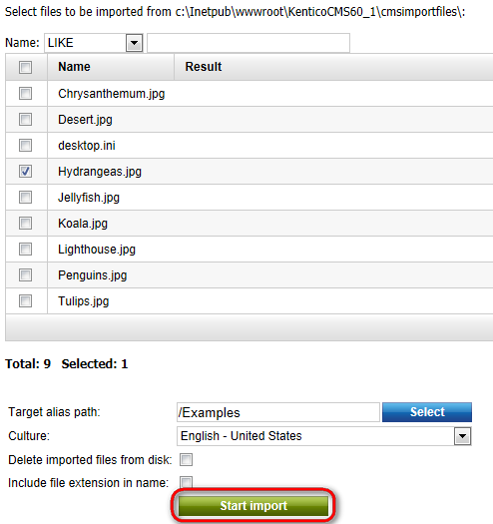

Congratulations, you’ve just imported selected file to your website.

Polls

Creating and publishing a new poll

- Go to Tools -> Polls.
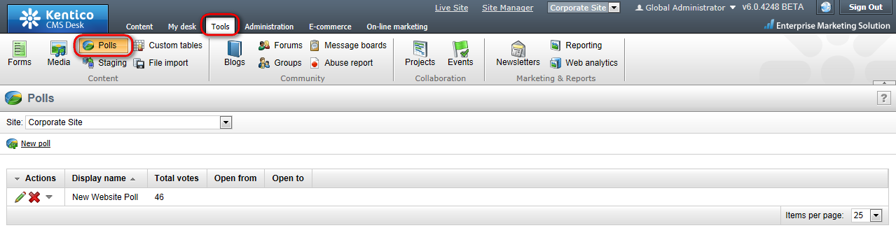
- Click New poll.
- The Display name, Code name and Title textboxes fill with Shopping. Into the Question textbox, enter the poll question: Have you ever bought anything from our website? and click OK.
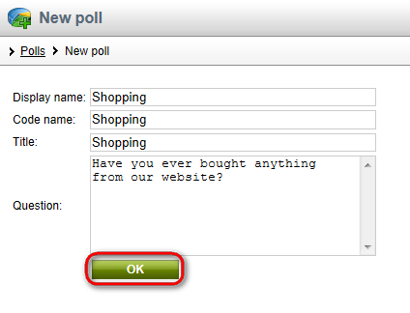
- Next, switch to the Answers tab and click New answer.
- Enter Yes as Text and click OK.
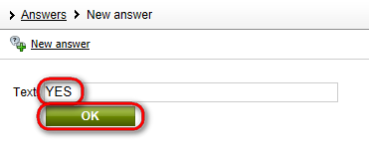
- Then click New Answer again. Enter No into the Text textbox and click OK.
- Now switch to the View tab to make sure that your poll looks the way you want it to.
- Your poll is ready, all you have to do is to publish it on your website. On the main menu, switch to the Content tab and choose the System Integration page in the content tree.
- Place the cursor into the Second Editable region and click the Insert poll button in the editor panel.
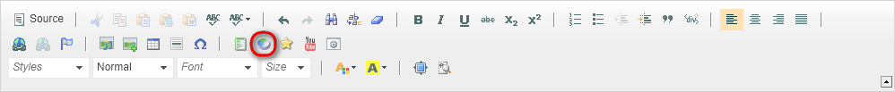
- In the displayed web dialog, click Select next to the Poll name field and choose the Shopping poll. Then click OK.
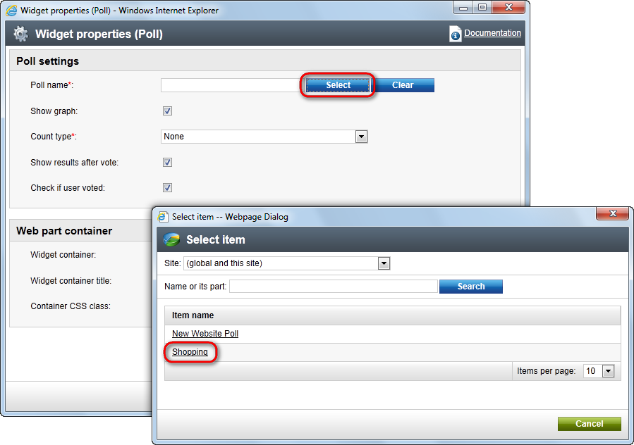
- Click Save and switch to the Preview mode to make sure that your poll is displayed correctly.
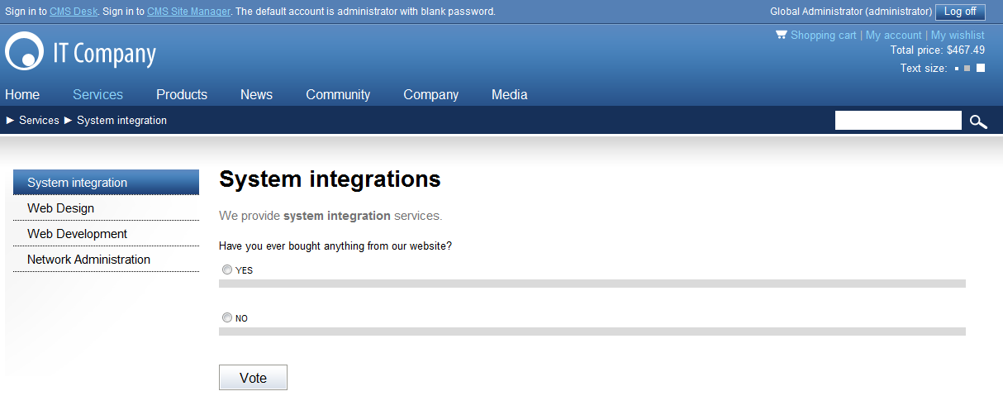
That’s how you create a poll and publish it on your website.

Forums

Creating a new forum

Please note: for this part of the guide, we assume that the forum group is already created for your website and it’s published. We also assumed that the users have the right to create forums.
- Go to Tools -> Forums.
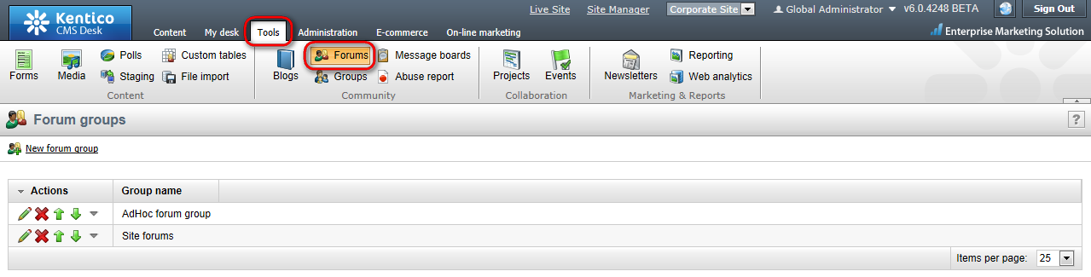
- Click Edit next to the existing forum group.
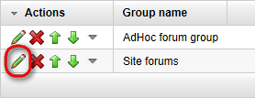
- Now click the Add forum button.

- Into the Forum display name and Forum code name textboxes, enter My new forum and MyNewForum respectively. Click OK.
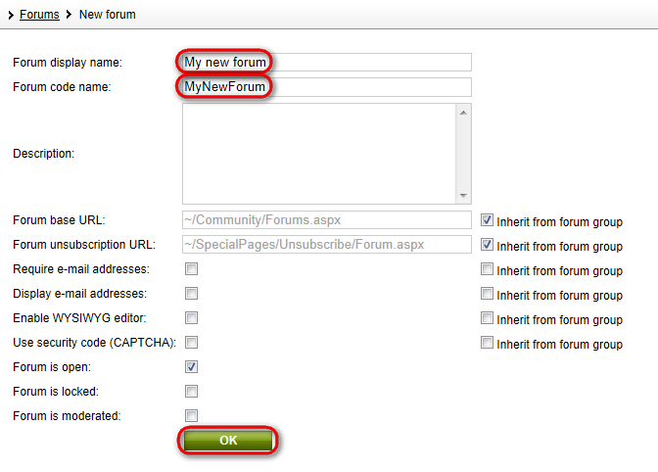

- You’ve just created your new forum. Now you’ll learn how to post a new thread. Click Sign out at the top-right.
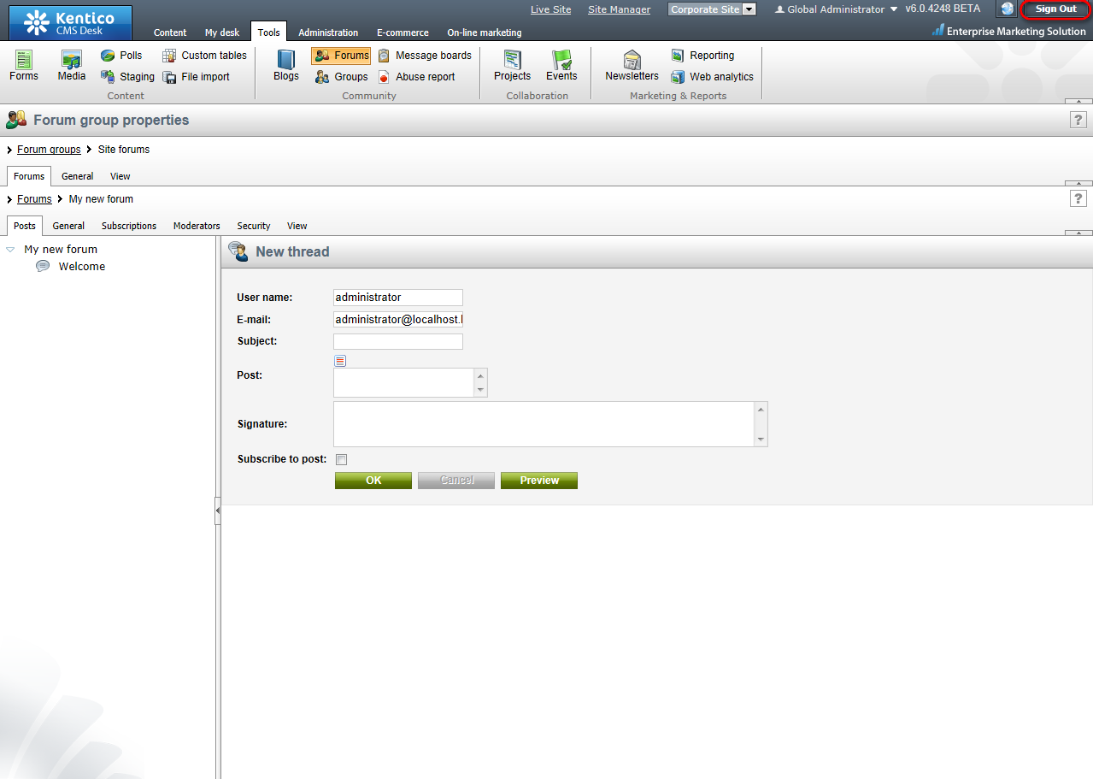

- You are redirected to the Home page of the Corporate site. Click Community -> Forums at the main menu.
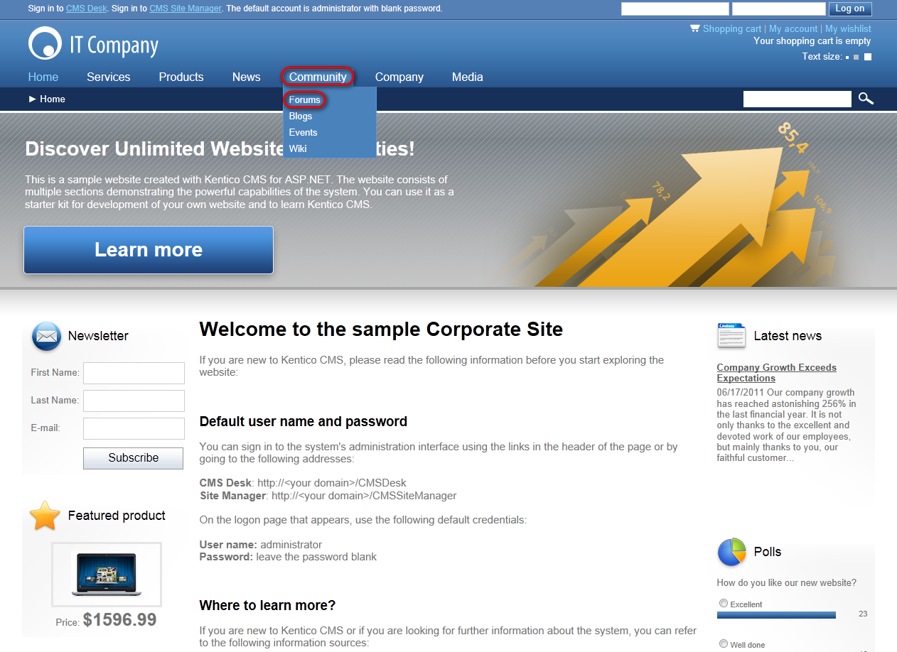
- In the Site forums section, click My new forum.
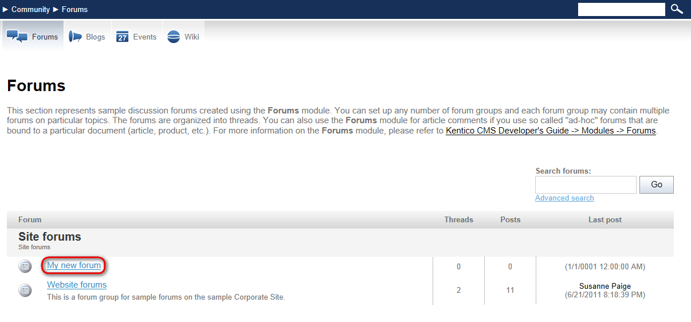
- Click the new thread button.
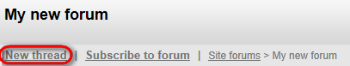
- Enter the following information:
- User name: Administrator
- E-mail: admin@gmail.com
- Subject: Welcome
- Post: Welcome to our new forum.
Click OK.
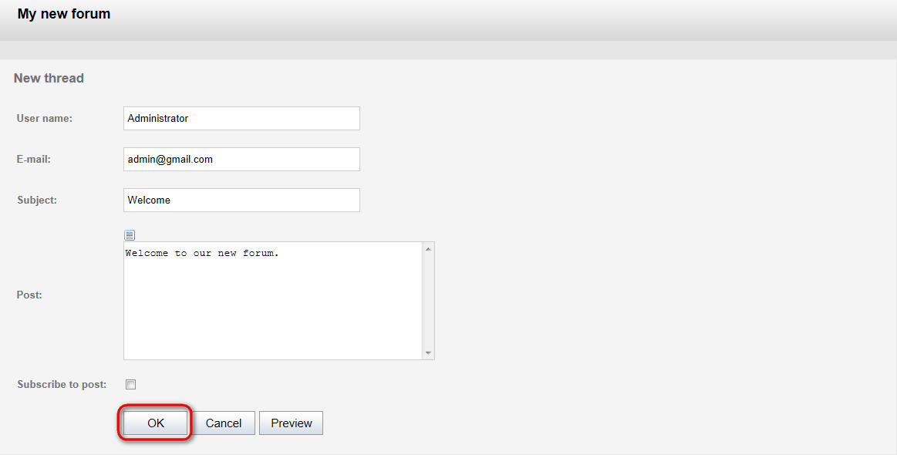
Congratulations, you’ve just created a new forum and posted the very first thread.
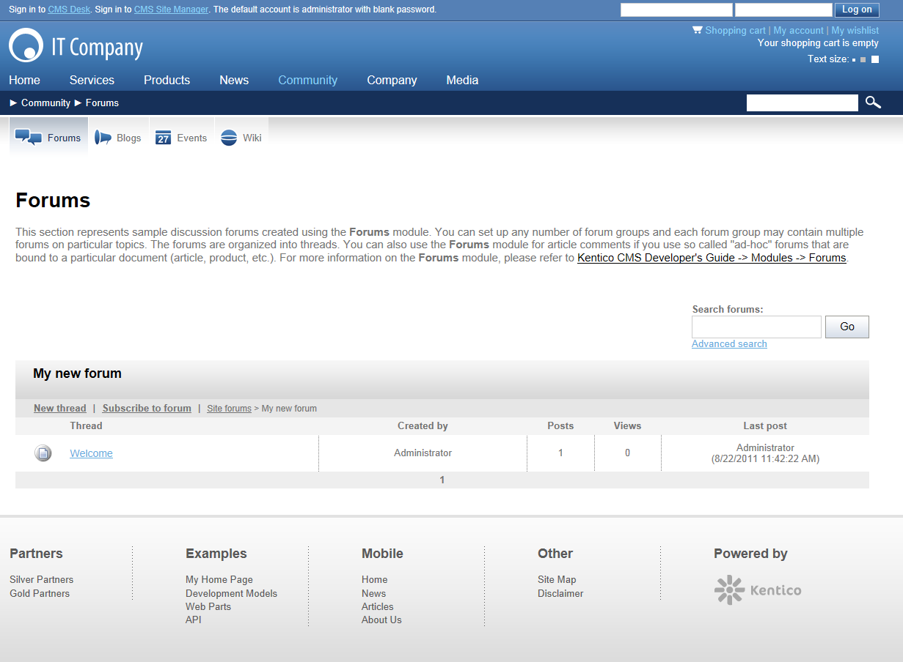

Moderating forum posts

Now you will learn how to create a moderate forum so that every post has to be approved before being published.
- Go to Tools -> Forums.
- Click Edit next to the existing forum group.
- Now click the Add forum button.
- Into the Forum display name, enter My moderated forum. Into the Forum code name, enter MyModeratedForum. Check the Forum is moderated checkbox. Then click OK.
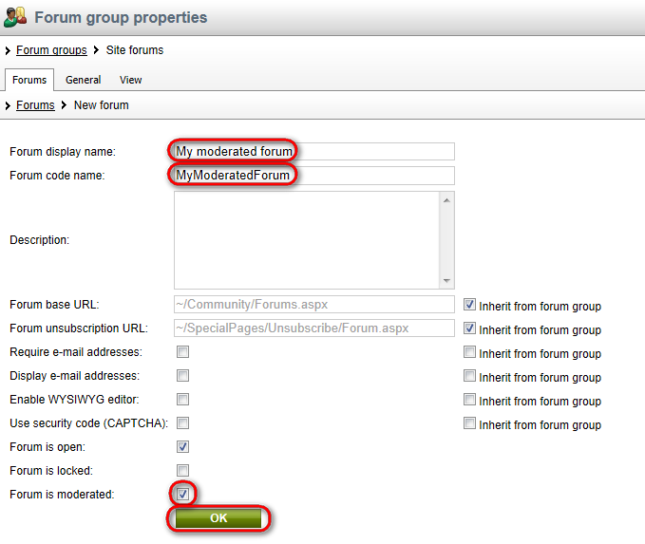
- As a global administrator, it’s not necessary to approve your own posts as they are being approved automatically. Therefore, to try out the approve functionality, please sign out from CMS Desk, go to the Forums section -> My moderated forum -> New thread and enter your user name and your e-mail address to the User name and the E-mail checkboxes. Next, enter Welcome as the Subject and to the Post textbox enter Come try our new moderated forum. Click OK.
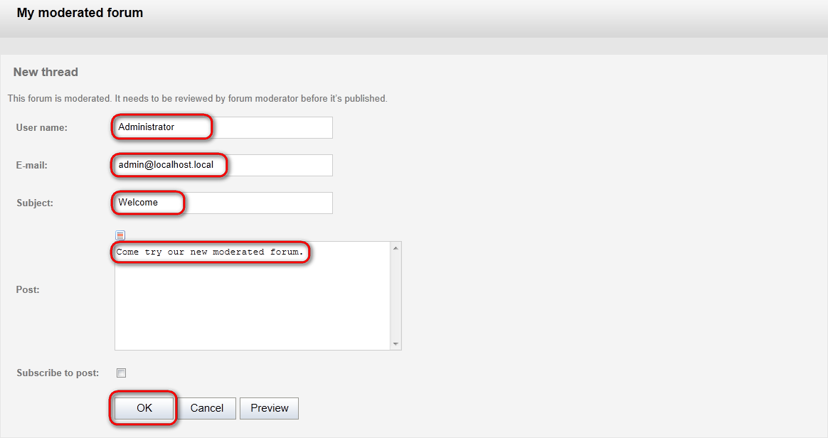

- The thread has been posted, however, to be visible in the forum, it has to be approved by the designated moderator.
Now, sign in back to the CMS Desk and navigate to: Tools -> Forums.
There are two ways how to approve the forum post. You can do that either on following screen by clicking Approve button:
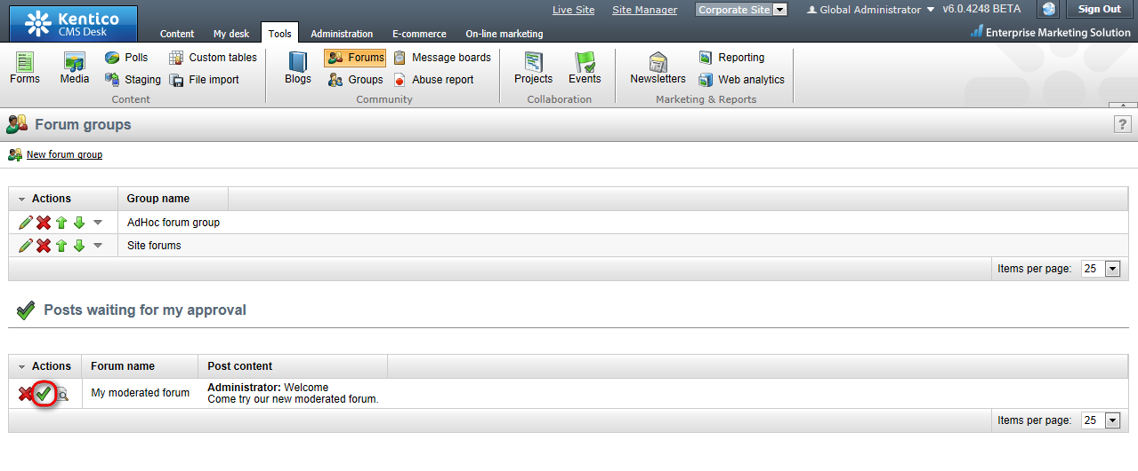
Or you can find particular forum post in the forum structure and approve it:
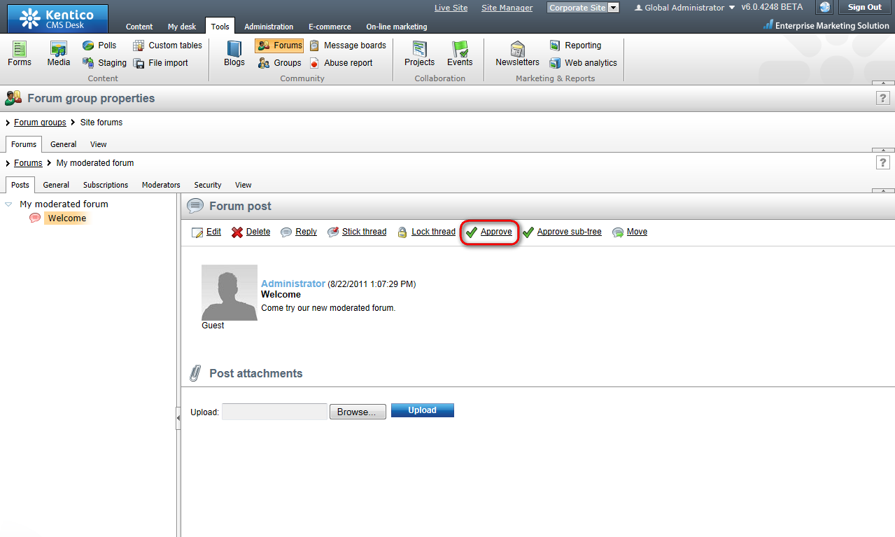
Congratulations, you’ve just approved your new thread and it’s visible on your website.

